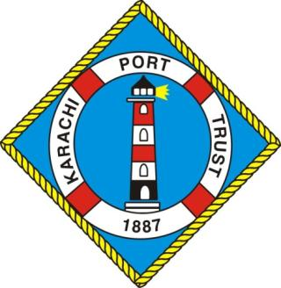

KPT YEAR BOOK
2024-25

Introduction
Karachi Port is the nation’s most important economic asset bearing a proud and distinguished history. A constant and on-going development programme based on scientific maritime principles has equipped the port to ably meet both the present and future requirements of cargo-handling. This impressive pinnacle of achievement has been reached after more than a century of development work and far-sighted planning.

History of the Port
By 1852, Karachi was an established city with a population of 14,000 and a prosperous overseas trade. The modern port began to take shape in 1854, when the main navigation channel was dredged and a mole or causeway was constructed to link the main harbour with the rest of the city.

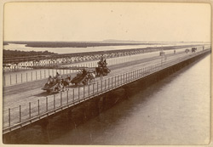
The photograph taken in 1900, with a general view along the iron Napier Mole Bridge connecting Karachi with Keamari, the landing place for all goods and passengers bound for the city. Karachi, now the capital of the Sindh province in the lower Indus valley, was once the capital of Pakistan and continues to be the country's commercial hub and largest city. Its history prior to the 19th century is largely unrecorded but it is believed to be the ancient port of Krokala on the Arabian Sea, visited by Alexander's admirals in 326 BC. Karachi is built around a bay which is a natural harbour and protected from storms by a group of small islands. The small fishing village of Karachi became a trading post when the Talpur Mirs of Sindh built a mud fort here in the 18th century, but the port remained small. It was completely transformed when its harbour was developed by the British after they conquered Sindh in the mid-19th century. The main navigable channel was dredged and the construction of a mole or causeway joining the main harbour with the rest of the city was undertaken. The Napier Mole Bridge was constructed about five years later, together with the Manora Breakwater, Keamari Groyne, Native Jetty and Chinna Creek.
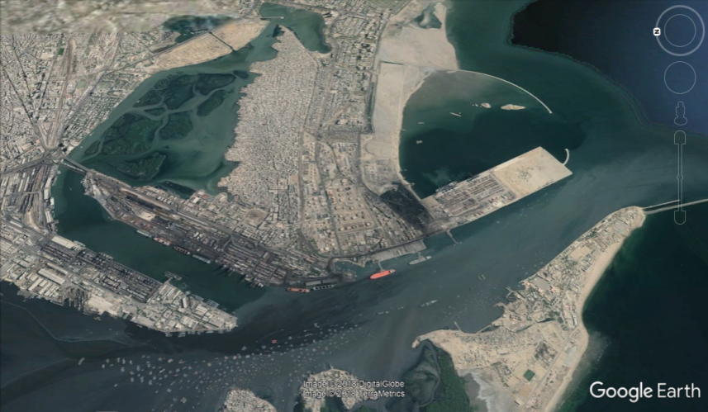
Location
In the northern coast of the Arabian Sea, from the straits of Hormuz in the west and past the Indus River in the east, lies about 600 kilometres of Pakistan’s serene coastline. Ideally located with well developed connections with Afghanistan, Central Asia and Western China; Karachi Port serves as gateway to the region.

Our Vision
To Transform Karachi Port into a User Friendly Transshipment-Transit Hub of the Region with Hinterland Connectivity

Governance Structure
Karachi Port is governed by the Ministry of Maritime Affairs. Chairman is the Chief Executive and also Chairman of KPT Board of Trustees. He is assisted by eight General Managers, responsible for the Operations, Finance, Planning and Development, Engineering, Administration, Civil Works, Real Estate Development and Legal Division(s). All policy decisions are vested in KPT Board of Trustees.

KPT Board of Trustees
The Board comprises eleven Trustees including Chairman. Chairman and five Trustees including one associated with Labour Unions are appointed by the Federal Government. Five Trustees are notified by Federal Government after they are elected / nominated by the respective bodies, i.e.
- Federation of Pakistan Chamber of Commerce & Industries
- Karachi Chamber of Commerce & Industry
- Karachi Cotton Association
- Pakistan Ship Agent’s Association
- Karachi Municipal Corporation

FACILITIES AT KARACHI PORT
Port Operations
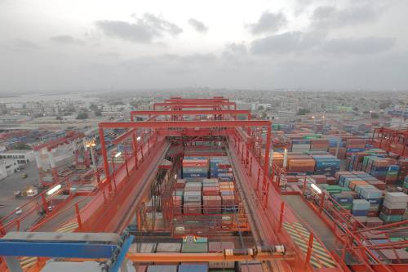
The containerized cargo started coming to Karachi Port from 1973. The American President Line has for the first time given service within a fortnight to bring 100 containers from US which was inaugurated by the then Prime Minister. Since then cargo freight has mostly shifted to containerized form and is growing every year.

KPT is poised to become the regional shipment hub, and its 3 world-class terminals serves major shipping lines connecting to ports all over the world. Spread out over almost 33 square kilo meters, KPT is a state of the art port with easy access for ships calling Karachi Port.

The Port itself consists of three wharves. The East Wharf has 17 multipurpose berths (Berth No. 1 to 17), the West Wharf has 13 berths (Berth No. 18 to 30) and the South Wharf has 4 berths
(Berth No. 31 to 34). Each of the wharves has a dedicated container terminal with a designed depth of 13-16 meters. The Karachi Port Trust has three oil piers to handle liquid cargo.

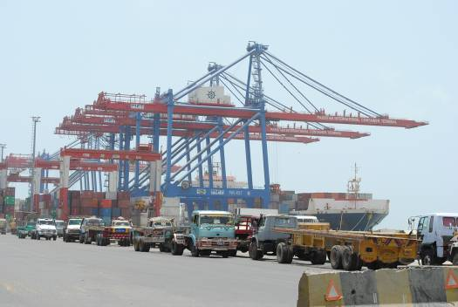
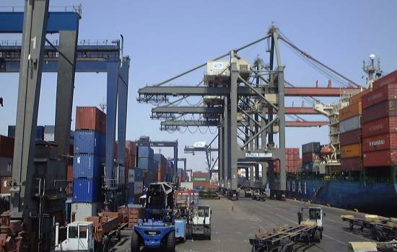
Container Facilities
Karachi International Container Terminal (KICT), Karachi Gateway Terminal Limited (KGTL) and South Asia Pakistan Terminals Limited (SAPTL) are the three dedicated Container Terminals located on the port developed in collaboration with private partnership and equipped with the latest cargo handling equipment.

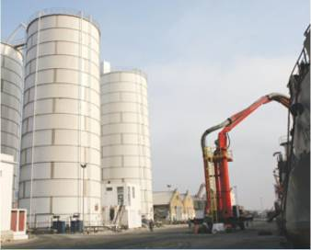
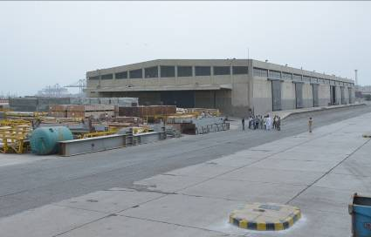
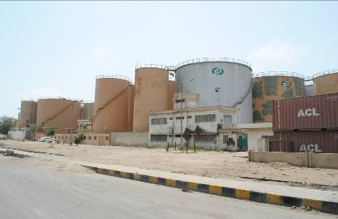
Warehousing Facilities
KPT provides facilities at each berth for transit, storage, warehousing and clearance of cargo and containers. Additional services are provided to port customers with respect to dangerous cargo handling at packing stations for immediate uploading and packaging of dry goods, custom storage yards, oil tank-ages, bulk cargo stacking areas and container freight stations.

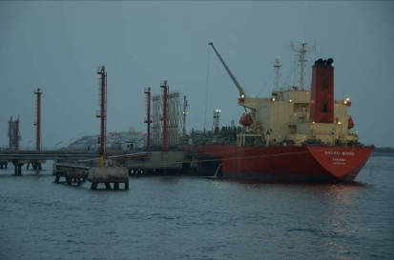
Liquid Cargo Terminal
KPT has three dedicated liquid cargo piers used for handling POL and non-POL products. These terminals are equipped with the most modern loading and unloading facilities backed by equally sound safety measures.

Ship Maintenance & Repair
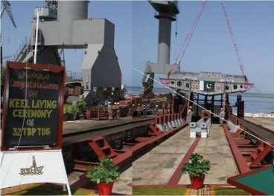
KPT has its own dry dock facility at Manora that enable quick boat repair and maintenance. For more extensive work, be it for larger ships; a shipyard run by Karachi Shipyard and Engineering Works is also located near the Port.

Port Safety & Security
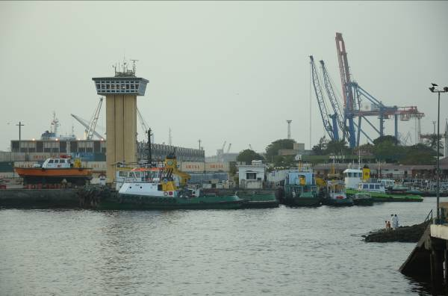
KPT is committed to the utmost safety and security of goods and personnel. A sophisticated system of radars, buoys, and technology system have been employed to monitor incoming vessels and, thereafter, to guide them to their berthing space. Additionally, the dedicated Port Security Force, Port Technology Units, Marine Pollution Control Department and Fire Fighting Unit at Karachi Port Trust works round the clock to provide security to Karachi Port that includes cargo and port users.

Dredging & Reclamation Work
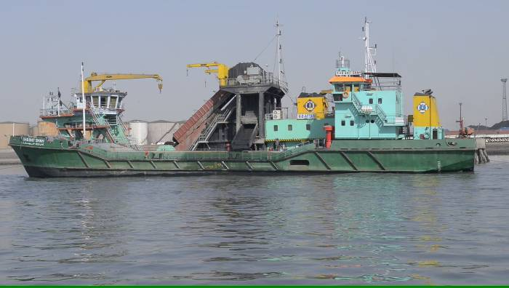
Dredging is a constant activity of a port and is conducted to maintain required depth at all times within the port channel to facilitate shipping lines and vessels calling Karachi Port. Due to high and low tides, the flow of tidal current brings siltation inside the channel which gradually reduces the depth inside the port channel. KPT has a flotilla of dredgers and is the sole port of Pakistan to have this facility. The Port has over the years remained in constant pursuit to acquire latest dredgers to meet its requirements.

DEVELOPMENTS
- KPT’s ongoing projects are as under:
  - Construction of Connectivity Bridge between East & West Wharves - Rs. 2,319 million
  - Reconstruction of Jetty at Boat Basin, Phase-II - Rs. 937 million

- KPT has following future projects:
  - Road Connectivity Projects:
KPT has developed an integrated road connectivity program for easing traffic congestion in and around the port area. Following projects are included in the plan:
S.No. | Projects | Cost(Millions)
A | Connectivity to Maripur Road | 3,008
B | Construction of an up-ramp to enter KGTL (PICT) | 440
C | Up-gradation of Shara-e-Ghalib between South Wharf and Bilawal Chowk | 1320
D | Construction of Flyover from SAPTL to KHAMIS Gate | 3800
E | Construction of Eastbay Expressway | 25,000
Total |  | 33,568 Million

  - Lyari Elevated Freight Corridor Project:
KPT submitted the concept proposal for the Economic Development Corporation Fund (EDCF) Loan through Ministry Of Maritime Affairs.The project was accepted by the Exim Bank Korea and they have appointed the consultant for preparing feasibility, which is expected to be completed by the end of December 2024.
  - Port Infrastructure projects (Reconstruction of Oil Pier-I)
KPT has plans to reconstruct Oil Pier-I which has outlived its useful life. The project has been designed by M/s Inros Lackner (Germany). The estimated cost of the project is Rs.13,000 Million.
  - Maintenance Dredging Works
KPT intends to dredge the existing channels via Maintenance Dredging of 04 MCM and project is around USD 30 Millions.
  - LNG and LPG Jetty at South Wharf:
KPT intends to multiply its investments at South Wharf KPT’s vision is to establish a State-of-the-Art Energy Hub to cater for energy shortages by LNG/LPG Jetty along with storage facility.

  - Business District / Financial Hub @ TPX
KPT intends to develop business district at 140 Acres land at TPX. Target businesses are Banks, Insurance companies, shipping companies and media houses.

ACHIEVEMENTS

Federal Minister Maritime Affairs Launched Ladies Cafe at KPT Head Office to Promote Women’s Empowerment
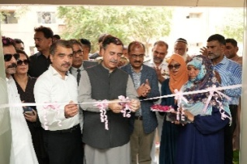
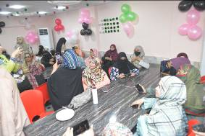
Federal Minister for Maritime Affairs, Mr. Muhammad Junaid Anwar Chaudhry, was the chief guest at the inaugural ceremony of the new Ladies Cafe at Karachi Port Trust’s Head Office. The facility was launched to foster a safe and secure environment for women employees, marking an important milestone in KPT’s efforts toward gender empowerment. Senior management officials and CBA office bearers were also present to witness this forward-thinking initiative, reinforcing KPT’s commitment to inclusivity and women’s empowerment within the port community.

Minister Muhammad Junaid Anwar Chaudhry Celebrates Academic and Women’s Empowerment Achievements at KPT
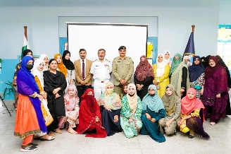
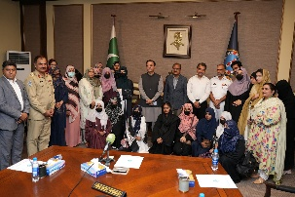
During his visit, Federal Minister for Maritime Affairs, Mr. Muhammad Junaid Anwar Chaudhry, participated in a special ceremony recognizing the outstanding academic achievements of 22 KPT School students who secured A-1 grades in their final matriculation exams. The Minister, alongside Mr. Parliamentary Secretary Mr. Darshan Lal and General Manager Administration Mr. Muhammad Younis, distributed cash prizes to students and teachers, celebrating their outstanding performances during the occasion.
The celebrations also marked the awarding of certificates to female students who completed a computer course at the KPT Industrial Home Computer Centre, highlighting KPT’s ongoing commitment to women education and empowerment. Mr. Junaid Anwar Chaudhry praised KPT’s efforts in fostering gender equality and youth development, making it a memorable day of progress and recognition for the port community.

Earlier, in a ceremony held on 18th February 2025, at the KPT Boys & Girls Secondary School Keamari, the certificates and cash prizes were also awarded by the then Acting Chairman KPT Rear Admiral Habib Ur Rehman to the students showing outstanding performances.

KPT Inaugurates Solarization of KPT Secondary School, Keamari

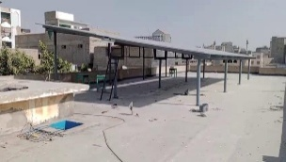
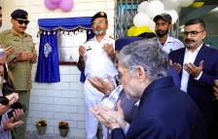
Karachi Port Trust has inaugurated the Solarization of KPT Secondary School in Keamari on 18th February 2025, marking a significant advancement towards sustainability and energy efficiency. This project features a 20 KW on-grid solar system, equipped with a fuel saver designed to decrease the school’s reliance on conventional electricity to promote renewable energy solutions. The installed solar panels, Jinko Solar 580-W N-type, adheres to the international standards, including IEC 61215, IEC 61730, ISO 9001, ISO 14001, and ISO 45001. This initiative aligns with KPT’s commitment to environmental responsibility and energy conservation.

The then Acting Chairman KPT Rear Admiral Habib Ur Rehman HI(M) attended the inauguration ceremony as the Chief Guest. In his address, he underscored the significance of renewable energy in minimizing carbon footprints and enhancing energy sustainability in public institutions.

KPT Port House Wins 2nd Prize at 74th Annual Flower Show
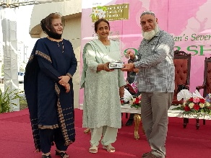
KPT Port House was awarded the 2nd Prize in the Official Large Bungalow category at the 74th Annual Flower Show Prize Distribution Ceremony, organized by the Horticultural Society of Pakistan on 20th February, 2025. KPT's then General Manager Civil Works, Mr. Hassan Arif Bilgrami, has received the coveted award for KPT during the event. This recognition highlights KPT's commitment to promoting greenery and enhancing aesthetics of its facilities.

Inauguration of Standby Generators at KPT Head Office
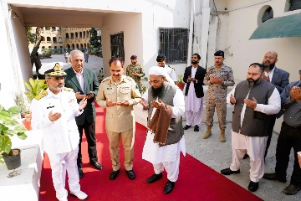
Rear Admiral Habib-ur-Rehman HI(M), the then Acting Chairman KPT, inaugurated the commissioning of two 650 KVA standby generators at the KPT Head Office on 3rd February 2025. It marks a significant modernization of KPT's power infrastructure, with an aim to ensure an uninterrupted energy supply that enhances operational efficiency round the clock.

During the inauguration, the chief guest praised the dedication of engineering team for putting in unwavering commitment and hard work to complete the project successfully. This development is a vital step toward realizing KPT's mission of providing excellent services.

The International Maritime Sustainability Exhibition and Conference (IMSEC) 2024
The International Maritime Sustainability Exhibition and Conference (IMSEC) 2024 event was inaugurated in Islamabad on 12th September 2024. The Deputy Prime Minister of Pakistan, Mr. Ishaq Dar, the chief guest during the occasion, was accompanied by the Federal Secretary of Maritime Affairs, Syed Zafar Ali Shah, and other notables. Thereafter, the event successfully continued in Karachi from 13th to 14th September 2024.
In Karachi, the conference was officially inaugurated by Mr. Arsenio Antonio Dominguez Velasco, Secretary-General of the International Maritime Organization (IMO). The ceremony was attended by Syed Murad Ali Shah, Chief Minister of Sindh, along with key officials including the then Federal Minister for Maritime Affairs, Mr. Qaiser Ahmed Sheikh, Additional Secretary Maritime Affairs, Mr. Umar Zafar Sheikh, and former Chairman KPT, Syedain Raza Zaidi.
During his address, the Chief Minister highlighted Karachi's strategic significance as the "Gateway to Pakistan" and expressed optimism for strengthening ties with IMO. He emphasized the crucial role of ports in facilitating maritime trade and reaffirmed the government’s commitment to environmental stewardship and adherence to international maritime regulations.
Secretary-General Velasco praised Pakistan’s commitment to maritime sustainability and acknowledged the Ministry of Maritime Affairs’ initiatives to explore new avenues for cooperation. He encouraged Pakistan to actively engage in global maritime efforts, stressing the significance of protecting trans-boundary species, minimizing ship pollution, and addressing plastic waste. Velasco advocated for the adoption of green maritime corridors and the use of alternative fuels, such as methanol.
Recognizing the challenges faced by Pakistan’s maritime industry, including a shortage of qualified seafarers, Velasco noted the vast opportunities for growth, given that 90% of global trade is conducted via sea routes. He urged the nation to enhance efficiency, sustainability while developing a comprehensive action plan to elevate maritime trade.
In closing, Velasco commended Pakistan’s hospitality and reiterated the importance of ongoing collaboration with the IMO to modernize ship recycling practices, encouraging the government to bolster the maritime economy and create more growth opportunities.
Subsequently, the Secretary-General of the IMO witnessed the Karachi Port Operations, KPT Hospital, and KPT Head Office, where he attended a cultural program hosted by Karachi Port Trust.

World Maritime Day 2024 Celebrated with Live Exercises at Oil Pier-II (PICS of RALLY and E0XERCISE)
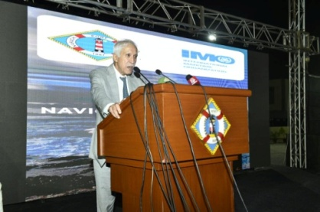
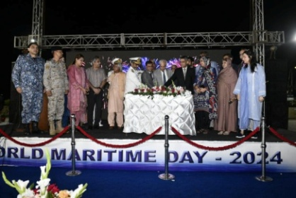
In celebration of World Maritime Day 2024, an impactful event was organized at Oil Pier-II, showcasing a live oil spill response exercise alongside a joint maritime security drill. The event highlighted the importance of preparedness and collaboration in ensuring maritime safety and environmental protection.
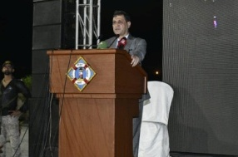
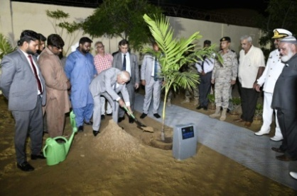
The exercises were conducted in partnership with the Pakistan Maritime Security Agency (PMSA), the Pakistan Navy, and the KPT Port Security Force, demonstrating a unified approach to addressing potential maritime challenges.
The Federal Minister for Maritime Affairs has graced the occasion as the chief guest.
The live demonstration showcased the coordination and efficiency of various agencies in managing oil spill incidents and ensuring maritime security. Participants engaged in realistic scenarios have tested their skills and response times, reinforcing the importance of training and preparedness in the maritime sector.

Karachi Port Trust Hosts Seminar on World Maritime Day Celebrations
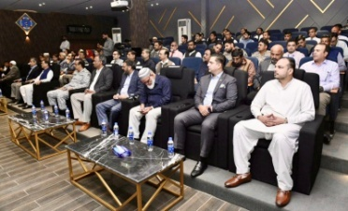
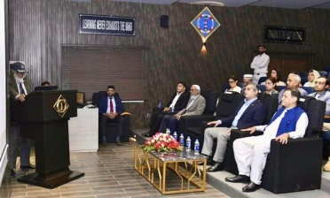
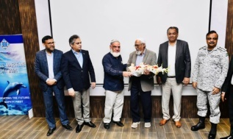
In celebration of World Maritime Day, the Karachi Port Trust organized a seminar at Staff College, focusing on key issues affecting the maritime industry. The event featured esteemed speakers, including Captain Rashid Anwar of Maritime Training Institute (MTI), who laid emphasis on the importance of safe navigation and effective vessel management.
Mr. Rashid Yahya Usmani of Pakistan Maritime Authority (PMA) also contributed to the discussions, shedding light on marine environmental protection, particularly in the context of climate change. His presentation highlighted the urgent need for sustainable practices within the maritime sector to safeguard our oceans and coastal ecosystems.
KPT Land Reclamation and Anti-Encroachment Initiatives
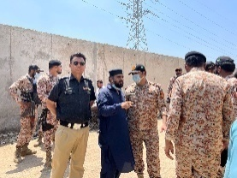
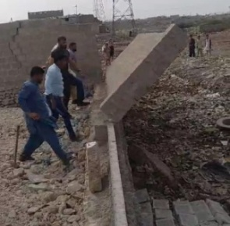

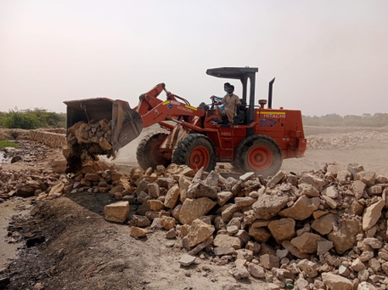
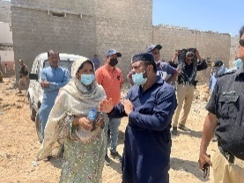
In alignment with the Prime Minister’s directive issued on January 21, 2025, Karachi Port Trust (KPT) successfully reclaimed approximately 100 acres of encroached land through coordinated efforts with the Government of Sindh, Pakistan Rangers, and other agencies. These efforts targeted strategic locations across Keamari, Sikandarabad, Younisabad, Machar Colony, Shireen Jinnah Colony, Sasti Basti, and Manora, among others.
Key reclamation activities included the recovery of land from areas such as Plot No.T-15 Boat Building Yard, Plot A-15 Mauripur Road, Plot 6/2 Keamari Township, and an unauthorized parking area on Tarachand Road, adding to future development, port expansion, and operational efficiency.
KPT’s anti-encroachment operations have been complemented by significant advancements in digitizing land records, enhancing transparency and security. The Anti-Encroachment Department has conducted 22 operations, apprehending individuals, and seizing vehicles across various locations. In a notable operation of 5 hours near Clifton Urban Forest, it resulted in the demolition of approximately 35,726 square yards of illegal structures only.
These ongoing efforts underscore KPT’s commitment to safeguarding maritime resources, maintaining public spaces, and ensuring the sustainable growth of Karachi Port.

Karachi Port Trust Establishes Sister-Port Relationship with the Port of Shanghai
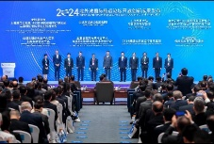
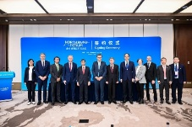
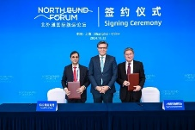
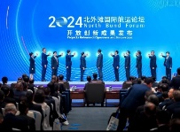
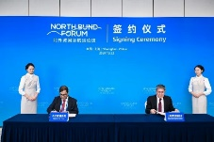
In a significant move to enhance maritime collaboration, Syed Syedain Raza Zaidi, the then Chairman KPT, signed a Memorandum of Understanding (MoU) on 22nd October 2024 to establish a sister-port relationship between the Karachi Port of the Islamic Republic of Pakistan and the Port of Shanghai of the People’s Republic of China. This important agreement was formalized during the North Bund Forum held in Shanghai, themed "Digital, Smart, and Green: Co-creation of a New Ecosystem of Global Shipping and Aviation."
The MoU aims to strengthen cooperation between the two ports, focusing on sharing best practices, technology, and sustainable development strategies by fostering a collaborative partnership. KPT and the Port of Shanghai aim to enhance operational efficiencies to contribute to the global shipping and aviation ecosystem.
This alliance is expected to open new avenues for trade and maritime services, reinforcing the position of Karachi Port as a key player in the region's shipping industry while bolstering the longstanding ties between the two friendly neighbors – Pakistan and China.
KPT Launched Free Computer Centre for Women
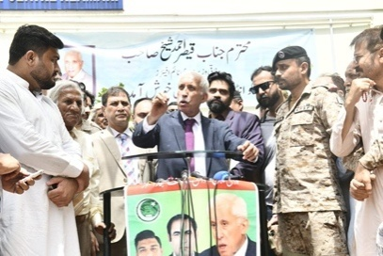
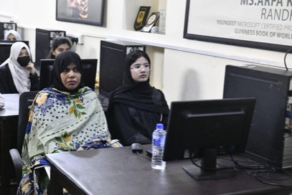
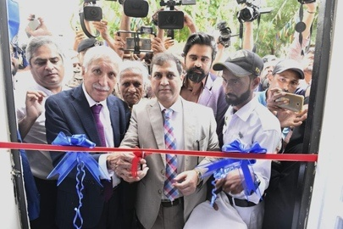
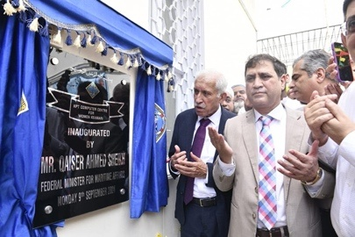
In a significant step towards empowering women, KPT officially inaugurated a free computer centre at the KPT Industrial Home, Keamari. The ceremony, attended by the then Minister for Maritime Affairs, Mr. Qaiser Ahmed Sheikh and Chairman KPT marked a new chapter in KPT's commitment in enhancing women skills, particularly for those residing in Keamari and surrounding areas.
The event was well-attended by KPT General Managers, officials, and community leaders, reflecting strong local support for this initiative and its impact on gender equality. Following the inauguration, the Federal Minister visited the KPT Sports Centre Keamari to conclude the proceedings.
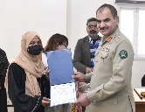
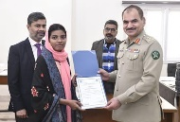
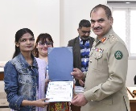
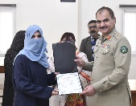
Karachi Port Trust Celebrates Graduation of First Microsoft Office Course for Women
KPT marked a significant milestone to train the first batch of the Microsoft Office Course, held at the KPT Computer Centre for Women in Keamari. This inaugural class, comprising 33 women, successfully completed the program, empowering women with the essential digital skills.
Brigadier Mohammad Younis, General Manager Administration, attended the ceremony and distributed certificates among the participants.
The KPT Computer Centre aims to provide free education and training to women from Keamari and surrounding areas. This initiative of KPT reflects on the ongoing efforts for enhancing and supporting the local community to acquire educational opportunities.
ACHIEVEMNENTS OF MEDICAL DEPARTMENT
- Installation of Solar Panel with goal of energy saving.
- Hiring of Specialist on fixed pay without any additional benefits which will substantially improve patient’s health care without financial burden on medical department with goal to reduce OPD Expenditure.
- Monthly free medical camp organized under the CSR at the far flung islands of Karachi. Till date 31 free medical camps are organized and approximately 28000 islanders are given free medical treatment. In addition neuropsychological assessment of children to prevent and detect psychological disorder also carried out in these camps; So far approx 5000 children are assessed in these camps.
- World Cancer Day Seminars was conducted by the medical department at KPT Staff College. These events aimed to unite the community through education, health initiatives and solidarity activities.
- Addition of equipment to reduce referral letter and expenditure.
- 01 Ultrasound Machine (ESOTE)
- 01 Biochemistry Analyzer (Blackman)
- Compliance of Direction of MOMA:
- Curtailment of Overtime.

TRAFFIC DEPARTMENT ACTIVITIES DURING YEAR 2024-25

- In pursuance of letter referred above, the achievement / significant events / Developments projects undertaken by Traffic Department, Operations Division during the fiscal year 2024-2025 are as under:

- The fiscal year 2024-25 marked a remarkable milestone for KPT, with overall cargo handling reaching 53.95 million tons and a record-breaking 2.65 million TEUs in container handling as the highest in KPT's history.
- Cargo handling operations, including Import and Export at Karachi Port Trust remained outstanding at the end of fiscal year 2024-25 and witnessed a notable rise of 4.45% in cargo handling. The entire freight closed at 53.95 million tons in which the Dry Cargo 41.68 million tons with 3.57% growth and Liquid Bulk Cargo 12.28 million tons with 7.56% increase. Similarly, the container handling at the Karachi Port Trust (KPT) reached a record 2.65 million TEUs in the fiscal year 2024-25.
- This marvel achievement and progressive performance is a testament of enhancement in KPT's operational capacity, infrastructure, and service efficiency that the port remained 24/7 operational even in the recent conflict between Pakistan and India.
- This exceptional growth, driven by a surge in both imports and exports, reflects KPT's vital role in powering Pakistan's trade and economic momentum. The vision of Government of Pakistan for enhancing Maritime Sector's capacity is being keenly monitored as well as mentored by Ministry of Maritime Affairs.
- A comprehensive analysis of KPT's freight operations during the fiscal year 2024-25 is enclosed at Annex-A.

COMPARATIVE CARGO/ CONTAINER HANDLING AT KPT
DURING 2023-24 & 2024-25 (JULY - JUN)

TYPE OF CARGO HANDLING | 2023-24 | 2024-25 | %age  GROWTH
TYPE OF CARGO HANDLING | (1 JULY – 30 JUN) |  | %age  GROWTH
IMPORTS (Million Tons)
Dry General Cargo | 18.269 | 21.365 | + 16.94
Dry Bulk Cargo | 4.313 | 1.407 | - 67.38
Total Dry Cargo | 22.582 | 22.772 | + 0.84
Liquid Bulk Cargo | 10.272 | 11.162 | + 8.66
TOTAL | 32.854 | 33.933 | + 3.28
EXPORTS (Million Tons)
Dry General Cargo | 13.399 | 12.250 | - 8.58
Dry Bulk Cargo | 4.260 | 6.657 | + 56.25
Total Dry Cargo | 17.660 | 18.907 | + 7.06
Liquid Bulk Cargo | 1.141 | 1.114 | - 2.38
TOTAL | 18.801 | 20.020 | + 6.49
TOTAL IMPORTS & EXPORTS (Million Tons)
Dry General Cargo | 31.669 | 33.615 | + 6.14
Dry Bulk Cargo | 8.573 | 8.063 | - 5.94
Total Dry Cargo | 40.241 | 41.678 | + 3.57
Liquid Bulk Cargo | 11.413 | 12.276 | + 7.56
GRAND TOTAL | 51.655 | 53.954 | + 4.45
CONTAINER HANDLING(TEUs in Million)
No. of Imports | 1.172 | 1.363 | + 16.32
No. of Exports | 1.105 | 1.288 | + 16.61
TOTAL TEUs | 2.277 | 2.651 | + 16.46
TERMINAL WISE BREAK DOWN (TEUs in Million)
KGTL | 0.415 | 0.398 | - 4.00
KICT | 0.681 | 0.660 | - 3.03
SAPTL | 1.171 | 1.586 | + 3.39
KPT BERTHS | 0.010 | 0.007 | - 27.25

HANDLING OF VESSELS & GRT (CUMULATIVE)

MOVEMENT | 2023-24 | 2024-25 | DIF. | Var%
ARRIVAL | 1,767 | 1,969 | - 202 | 11.4%
DEPARTURE | 1,766 | 1,952 | - 186 | 10.5%
SHIFTING | 288 | 270 | - 18 | -6.3%
TOTAL MOVEMENTS | 3,821 | 4,191 | + 370 | 9.7%

GRT | 79,729,911 | 86,257,982 | +6,528,071 | 8.2%

VESSEL TYPE | 2023-24 | 2024-25 | DIF. | Var%
CONAINER | 996 | 1093 | + 97 | 9.7
KICT | 314 | 300 | - 14 | -4.5
KGTL | 148 | 189 | + 41 | 27.7
SAPT | 520 | 593 | + 73 | 14.0
KPT | 14 | 11 | - 3 | -21.4
TANKER | 413 | 453 | + 40 | 9.7
BULK | 209 | 217 | + 8 | 3.8
GENERAL CARGO | 119 | 167 | + 48 | 40.3
CAR CARRIER | 13 | 14 | + 1 | 7.7
MISC(Navy, Bunker, Repair etc) | 14 | 25 | + 8 | 47.1
TOTAL | 1767 | 1969 | + 202 | 11.4

- Vessel Movement at Karachi Port grew by 11% in FY 2024-25, totaling 1969 vessels including 1,093 containers, 218 bulk, 180 general cargo, 453 liquid cargo and 25 Misc vessels.

- In Jan 2025, KPT handled MSC Oscar with a record GPT of 192,237 MT as the highest ever at Karachi Port.

- A significant increase in GRT @8.2% greater than previous financial year, attribute to the substantial growth in import / export quantum and the membership arriving at Karachi port.

- The highest GRT 86,257,982 MT handled in fiscal year of 2024-2025 which is the historical record so far in the history of KPT.

- Refurbishment / Maintenance of all channel Buoys in Approach Channel &Tipu Sultan Channel were undertaken by KPT utilizing its own resource and expertise.

CORPORATE SOCIAL RESPONSIBILITIES
KPT Distributes Ramadan Packages
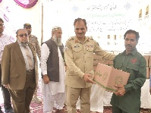
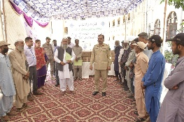
In a generous gesture of support during the holy month of Ramadan, Karachi Port Trust distributed Ramadan packages to around 600 daily wage employees and janitorial staff at the KPT Head Office on 10th March, 2025.
The distribution was officiated by Brig. Muhammad Younis, General Manager Administration. This initiative is a commitment of KPT towards Corporate Social Responsibility that aims to uplift welfare of its employees and their families during the blessed month.

EVENTS

The Honorable Prime Minister of Pakistan visited Karachi Port Trust Head-Office
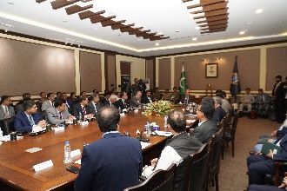
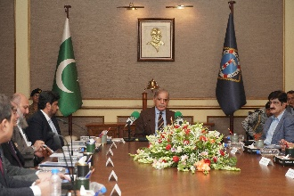
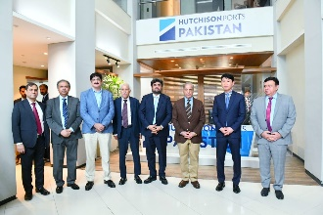
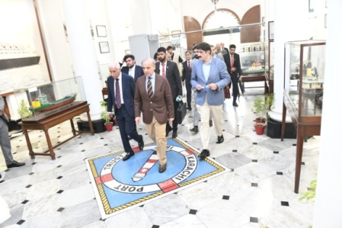
The Honorable Prime Minister of Islamic Republic of Pakistan,Mian Muhammad Shahbaz Sharif visited Karachi Port Trust Head Officeaccompanied by Governor of Sindh Mr. Kamran Tessori, the Chief Minister of Sindh Syed Murad Ali Shah and other Federal Ministers. Chairman KPT ‘Syedain Raza Zaidi’ briefed the delegation on Port Operations. The Prime Minister emphasized the needfor better coordination amongst all stakeholders. He also visited South Asia Pakistan Terminal (SAPTL) to witness port operations.

Minister for Maritime Affairs Muhammad Junaid Anwar's Visited KPT
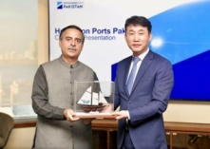
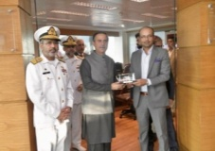
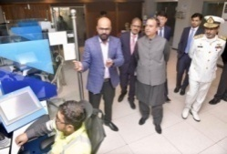
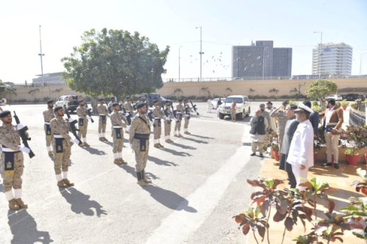
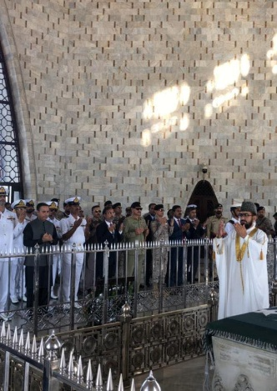
The Federal Minister for Maritime Affairs, Muhammad Junaid Anwar, conducted a significant visit to Karachi Port Trust (KPT) and its associated facilities on 24th March, 2025,. The Minister’s visit began with a solemn tribute at the Quaid-e-Azam's Mausoleum, where he laid a wreath to honour the founding father of the nation, accompanied by senior management officials from KPT and other departments of the Ministry.
Following this respectful homage, the Minister proceeded to the KPT Head Office, where he was warmly welcomed by Chairman KPT Rear Admiral Habib-ur-Rehman, alongside senior management officials of KPT. A briefing on KPT's strategic operations and ongoing initiatives was given to the Minister during the occasion.
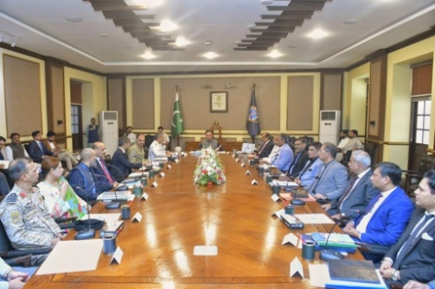
Continuing his engagement, the Minister Junaid Anwar held discussions with the KPT Board of Trustees, emphasizing the importance of collaborative efforts in enhancing port operations and services. He also interacted with representatives from various trade unions of KPT and KDLB, acknowledging their vital role in supporting the port's workforce and in improving working conditions. During the occasion, he also gave approval to release bonuses to KPT employees and performed plantation in KPT Head Office.
The visit culminated with a tour of the port area, where the Minister Junaid Anwar received a further briefing from terminal operators with regards to their operations and future projects. His keen interest in the terminal operations reflected his commitment to optimizing maritime activities and ensuring the overall growth of the port.
This visit established a framework for ongoing dialogue and cooperation between the Ministry of Maritime Affairs and KPT, reinforcing their shared commitment to the development of Pakistan's maritime sector.
Minister Muhammad Junaid Anwar Chaudhry Witnesses Oil Spill Response Exercise at KPT
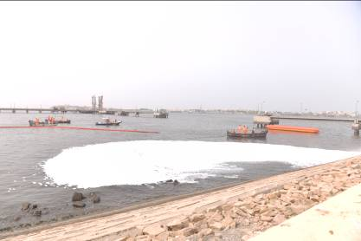
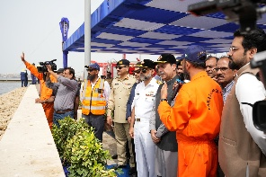
Federal Minister for Maritime Affairs, Mr. Muhammad Junaid Anwar Chaudhry, observed an Oil Spill Response Exercise at Oil Pier-II on June 3rd, 2025. General Manager Operation Rear Admiral Atiq ur Rahman HI(M) briefed the Minister about conduct of Mock Exercise and its importance in maintaining currency of operation as well as operational availability of OSR Equipment, underscoring the port’s preparedness to effectively manage environmental emergencies. KPT handles approximately 12 million tons of liquid cargo annually. In line with Pakistan’s commitment as a signatory of OPRC 90, KPT has enhanced operational capacity and remains an integral part of the National Maritime Disaster and Contingency Plan (NMDCP).
The minister underscored that such exercises improve the response team skills in containment, cleanup, and mitigation, ultimately minimizing environmental damage during actual incidents.

Federal Minister Muhammad Junaid Anwar Chaudhry Inaugurated 300 kW Solar Power Plant at KPT Izhar Abbasi Hospital
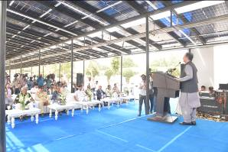
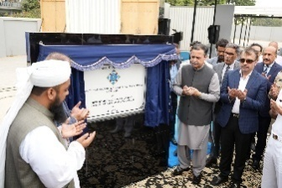
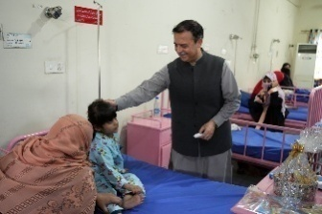
In a significant step towards sustainability, the Karachi Port Trust inaugurated a new 300 kW solar power plant at Izhar Abbasi Hospital, with Federal Minister for Maritime Affairs, Mr. Muhammad Junaid Anwar Chaudhry, serving as the chief guest. The event underscored KPT’s commitment to green energy for reducing environmental impact. During his visit, the Minister also toured the hospital facilities to observe the healthcare services provided to patients, reaffirming KPT’s focus on health and environmental sustainability for the community.

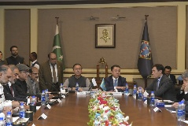
A High-Level Kazakhstan Delegation Visited KPT Head Office
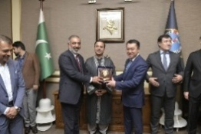
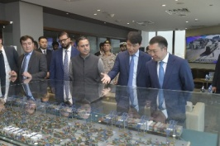
In a series of high-level engagements to bolster regional cooperation and investment prospects, a distinguished Kazakhstan delegation led by Minister for Transport, H.E. Murat Karimzhanovich Karabayev, visited KPT facilities on 28th April 2025. The delegation, accompanied by the Federal Minister for Maritime Affairs, Mr. Muhammad Junaid Anwar Chaudhry, toured the SAPTL terminal to observe port operations and discussed avenues for enhancing bilateral maritime collaboration with senior KPT management.
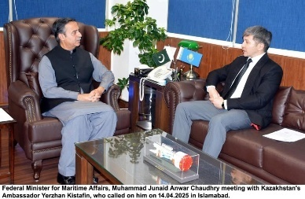
Earlier this month, on April 14, 2025, Minister Chaudhry also held a significant meeting with Kazakhstan’s Ambassador to Pakistan, Yerzhan Kistafin. During the discussions at the Minister’s office, the focus remained on strengthening diplomatic and economic ties, with respect to the investment opportunities available at Karachi Port.
Moreover, various avenues of cooperation, collaboration and investment opportunities for both the countries were discussed during the occasion which concluded with the exchange of souvenirs.

The Federal Minister for Maritime Affairs witnessed KPT’s Fire Drills
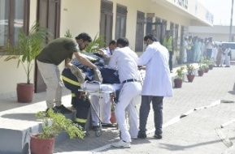
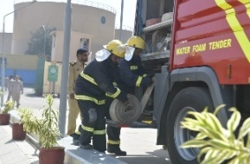
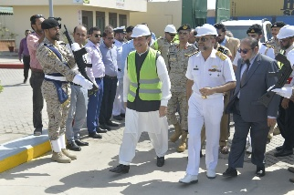
Minister for Maritime Affairs Muhammad Junaid Anwar witnessed the firefighting drills at Oil Pier-2, showcasing the exceptional professionalism and swift response of the KPT Fire Department on 29th April, 2025. The demonstration included fire extinguishing, rescue operations, and salvage of important documents and equipment, highlighting the department’s preparedness for emergencies in sensitive areas.
The Minister praised the firefighting team for their vigilance and quick action, emphasizing the importance of regular drills in maintaining safety standards. KPT emergency services reaffirmed their commitment to collaboration, stating they will assist the City Government of Karachi in case of a city-wide fire incident.
Following the drills, Minister Junaid Anwar toured the facilities and expressed his satisfaction with the Port’s safety measures and infrastructure readiness.
___________________________________________________________________________
Federal Minister chaired a Meeting to Review CSR Activities
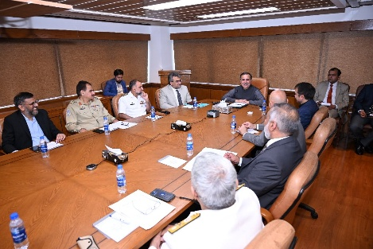
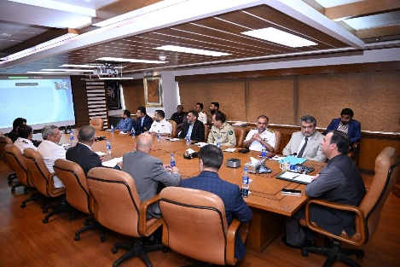
The Federal Minister for Maritime Affairs Muhammad Junaid Anwar Chaudhry presided over a key meeting at the PNSC building to review CSR activities on 30th April 2025. The session was attended by high officials of Karachi Port Trust, Port Qasim Authority, Pakistan Maritime Academy, and CEO Pakistan National Shipping Corporation. The meeting focused on strengthening corporate social responsibility initiatives within the maritime industry, emphasizing the importance of community development and sustainable growth in the sector. The attendees discussed the ongoing projects and thereby explored new opportunities to promote social welfare and environmental sustainability.
KCCI Delegation visits KPT with a strategic aim to boost national trade
A high level, 35 members, delegation of Karachi Chamber of Commerce and Industries (KCCI) led by Chairman BMG Zubair Motiwala and the President KCCI M. Javed Bilwani visited Karachi Port Trust (KPT) on the invitation of the KPT Board of Trustees/KPT Transition Management Committee (TMC) with a strategic aim of boosting national trade. The meeting was chaired by the KPT TMC members Abdullah Zaki and Faheem Ur Rehman Saigol which was well attended by the senior management officers of KPT besides the delegates.
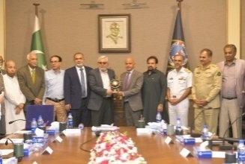
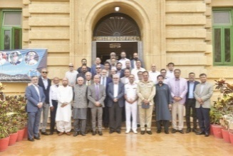
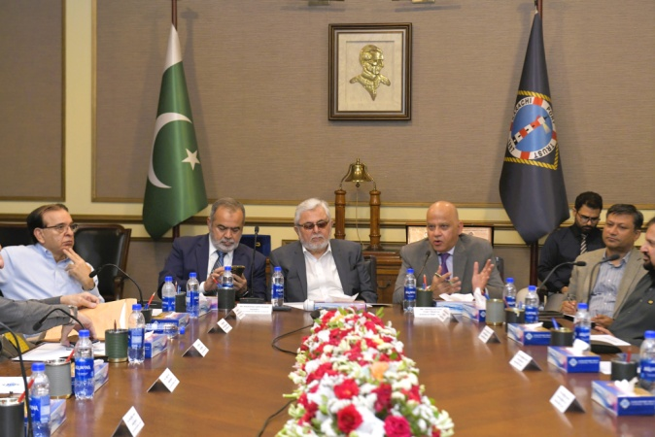
A briefing on facilities available at KPT was given in connection with the Export Finance Scheme initiative of KCCI and thereafter avenues of boosting national trade with efficient port operations and infrastructure development initiatives perused by the KPT came under discussion during the meeting. The KCCI Delegation also shared some valuable insights for further improving the port logistics while plugging in procedural bottlenecks that harms a business friendly environment.
Both the KPT and KCCI showed commitment to work jointly with positive demeanor for streamlining trade operations as well as for attracting investments in the business and maritime sectors of Pakistan. The focus remained at evolving policies that benefits the commercial and trade sectors should the port thrives to become regional hub as envisioned by the government.
The TMC as well as the senior management officers of KPT appreciated the initiatives taken by KCCI as voice of the trade community in strengthening national trade and concluded on a note to jointly explore avenues of engagement and collaboration to further augment national trade.

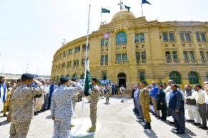
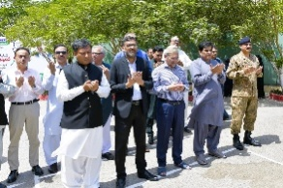
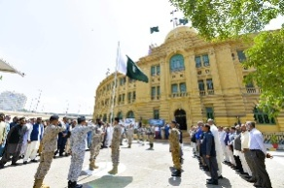
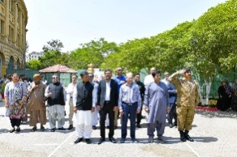
KPT Celebrates Youm-e-Tashakur: Honoring Pakistan’s Victory
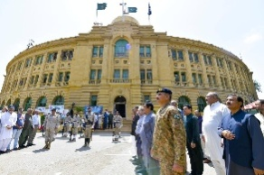
KPT celebrated “Youm-e-Tashakur” on 16th May 2025, to honor Pakistan’s historic victory over Indian aggression. The event underscores the resilience and strength of the nation.
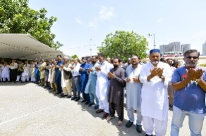
A significant parade, organized by the Port Security Force at KPT Head Office, was attended by senior officials including all distinguished General Managers. The gathering reflected the unity and patriotic spirit of KPT officers and employees.
The ceremony proceeded with the flag hoisting followed by dua for the nation's well-being and continued progress of the nation as well as KPT. During the occasion, a tribute to Pakistan Armed Forces for their bravery and valor for defending the motherland during Operation Bunyan-um-Marsoos, that resulted in thwarting the Indian hegemonic designs.

Kazakhstan Delegation Visits KPT to Explore Maritime Collaboration Opportunities
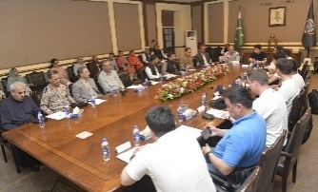
A delegation of nine representatives from Kazakhstan visited KPT Head Office on 25th April, 2025, to explore avenues of mutual interest in the maritime sector of Pakistan. The visit reflects ongoing efforts to strengthen regional cooperation and expand bilateral maritime collaborations.
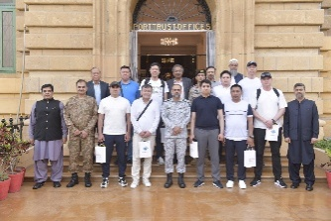
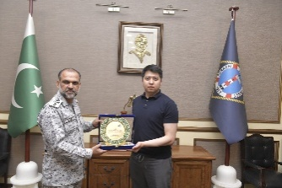
This visit followed the meeting between Kazakhstan’s delegation and the Federal Minister for Maritime Affairs earlier this month, emphasizing Kazakhstan’s growing interest in Pakistan’s maritime infrastructure. The engagement underscores the importance of collaborative efforts to foster regional connectivity to enhance maritime trade between the two nations.
During the visit, General Manager Operations Rear Admiral Ateeq-ur-Rehman HI(M) provided a detailed briefing on KPT’s infrastructure, operational capabilities, and upcoming development projects, highlighting the port’s strategic role in regional trade and economic growth.
___________________________________________________________________________

KPT Hosts Strategic Presentation by Kearney-MTBS Team on Master Plan Framework
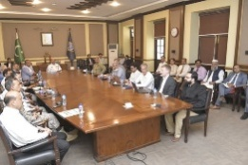
A comprehensive presentation was delivered by the Kearney-MTBS team at KPT Head Office on 15th April, 2025. The session focused on the Master Plan Framework, high-level target flows, key drivers, maritime traffic projections, and various scenarios to test the sensitivity of traffic estimates. The presentation chaired by General Manager Operations Rear Admiral Atiq-ur-Rehman was attended by senior and middle management officers of KPT.
The discussion aimed to refine the port’s strategic development plans, enhance operational efficiency that supports sustainable growth in line with future maritime industry demands.
WAPDA Delegation Visits KPT Head Office for Port Operations Briefing
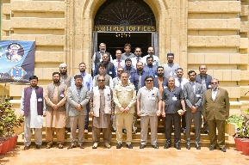
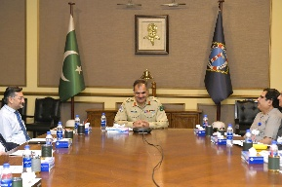
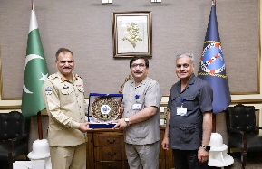
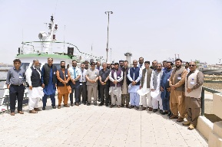
A delegation of 25 participants from the 150th Middle Management Course at WAPDA Administrative Staff College, accompanied by 2 faculty members, visited KPT Head Office on 20th May, 2025. Brigadier Muhammad Younis, KPT General Manager Admin, chaired the meeting.
During the visit, a detailed briefing on port operations and future development plans were given. The delegation expressed keen interest in KPT’s ongoing projects and asked insightful questions regarding dredging, cargo handling, dwell time, and overall port efficiency.
The event concluded with an exchange of crest ceremony followed by harbour cruise, to the delegation during occasion.
___________________________________________________________________________
KPT Ensures Emergency Preparedness at Key Facilities Amid Heightened Security Concerns
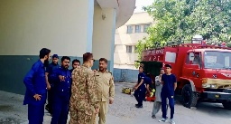
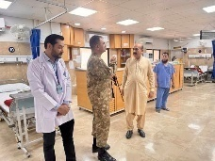
General Manager Admin, Brig Muhammad Younus visited the Izhar Abbasi Hospital and KPT Central Fire Station to review its emergency facilities and evaluate its readiness to handle urgent situations, including potential scenarios within the port premises or nearby areas during the Pakistan-India tensions and Operation Bunyan-Um-Marsoos.
These combined efforts underscore KPT’s commitment to maintaining a rapid and efficient emergency response capability, reaffirming its pledge to be at the forefront in safeguarding the port community and the nation against security challenges posed by external threats.
Uzbek Delegation Visits Karachi Port Trust to Strengthen Pakistan-Uzbekistan Maritime Ties
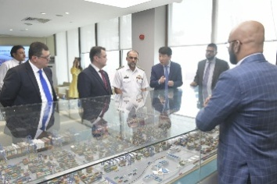
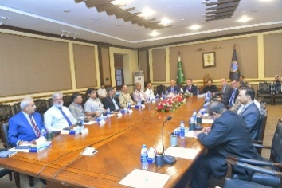
A three-member delegation led by Uzbekistan’s Ambassador, Alisher Takhtayev, visited KPT to explore cooperation and investment opportunities in Pakistan’s dynamic maritime sector on 26th June 2025. The visit signifies a pivotal step in enhancing regional maritime collaboration and boosting business ties between Pakistan and Uzbekistan.
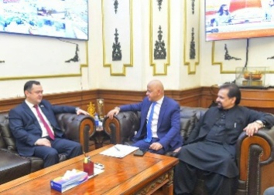
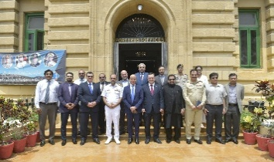
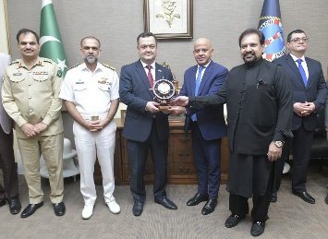
The delegation, including senior officials and business representatives, was welcomed by KPT’s Transition Management Committee members, Abdullah Zaki and Khawaja M. Zubair, who provided insights into Pakistan’s blue economy and Karachi Port’s vital role in trade facilitation and infrastructure development. Discussions highlighted potential projects in cargo handling, logistics, and the Maritime Business District, emphasizing Pakistan’s commitment to sustainable maritime growth.
KPT’s management showcased the port’s modernization efforts, including its advanced terminal operations, which attracted keen interest from the Uzbek side. The visit reflected Uzbekistan's strategic interest in port expansion and investing within Pakistan’s blue economy, especially to enhance connectivity for landlocked Uzbekistan to global markets.
The visit followed a key meeting between the Uzbek Ambassador and Pakistan’s Federal Minister for Maritime Affairs, Muhammad Junaid Anwar Chaudhry, who reaffirmed Pakistan’s dedication to regional cooperation and exploring new economic avenues with Central Asian nations.
KPT Partners with Karachi Shipyard for obtaining Mooring Boats
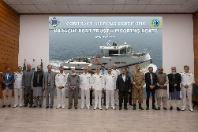
In alignment with the directives of the honourable Prime Minister of Pakistan, Karachi Port Trust has signed a contract agreement with Karachi Shipyard & Engineering Works on 7th March 2025 for the construction and supply of two new mooring boats.
(include details of facilities that mooring boats provide)
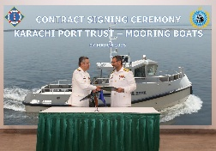
The agreement was signed by Chairman KPT Rear Admiral Habib-ur-Rehman HI(M) and Managing Director KSEW Rear Admiral Salman Ilyas HI(M). The addition of these mooring boats will significantly enhance KPT's operational capabilities, facilitating berthing and unberthing processes, preventing vessel collisions, towing and escorting, line handling, and supporting cargo operations. Additionally, they will play a crucial role in spill response and waste management efforts.
______________________________________________________________________________
Karachi Port to Benefit from Dedicated Freight Corridor and Multi-Modal Logistics Park
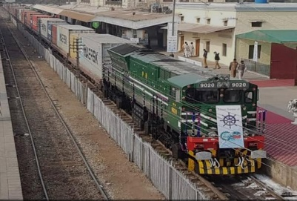
Karachi Port is poised to gain significant advantages from the upcoming Dedicated Freight Corridor and Multi-Modal Logistics Park in Pipri. The initiative will transit freight transport from roads to railways, resulting in reduced traffic congestions, lower pollution levels, and minimized road damages.
The project is expected to enhance business opportunities, thereby boosting the city’s economy and daily lives of residents. This effort represents a substantial step towards promoting a cleaner, smoother, and more sustainable Karachi, ultimately benefiting the entire community.
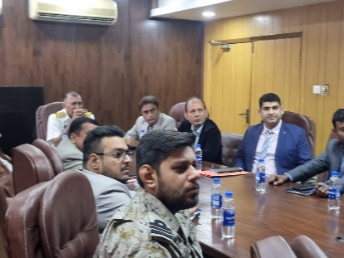
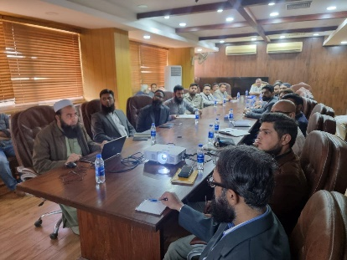
KPT Partners with PQA to Implement E-PAD Module for Procurement Transparency
KPT officials visited Port Qasim Authority (PQA) On 23rd January 2025 to foster collaboration on implementation of the E-PADS (E-Pakistan Acquisition & Disposal System) module. The KPT team comprising representatives from Operations, Engineering, Planning and Development, and Civil Works Divisions were warmly received by the Director General Technical Rear Admiral Hussain Sial.
The E-PADS module is designed to enhance transparency in procurement processes, allowing suppliers to effectively register for goods, works, and services. It streamlines the entire procurement cycle, from planning to contract closure, promoting efficient and transparent practices that benefits all involved in the procurement process. KPT stands committed to modernize its operations while ensuring integrity in procurement activities.
Visit of National Assembly Standing Committee on Maritime Affairs
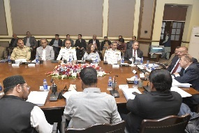
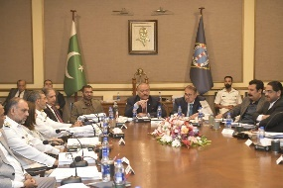
A meeting of the National Assembly Standing Committee on Maritime Affairs, chaired by Mr. Abdul Qadir Patel (MNA), held at KPT Head Office on 6th February 2025. The meeting remained focused on several critical topics, including maritime issues, legal matters, anti-encroachment efforts, and matters related to estate and human resources.
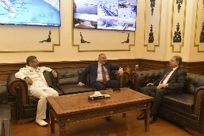
The Federal Secretary on Ministry of Maritime Affairs, Director General (Ports and Shipping), KPT Board of Trustees, and all the General Managers have attended the meeting. The discussion provided an opportunity to elaborate ongoing challenges and strategies and above all on reinforcing KPT's commitment towards effective governance and operational excellence.

KPT Showcased Maritime Contributions and Strategic Importance at IDEAS 2024
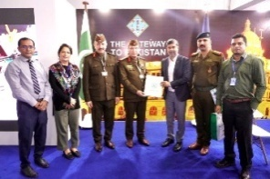
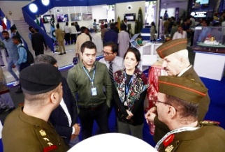
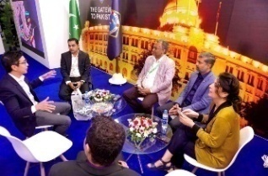
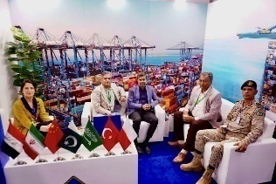
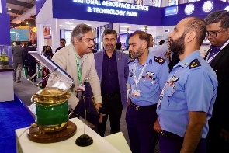
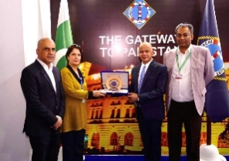
KPT made a significant impact at the International Defence Exhibition and Seminar (IDEAS) 2024, held from 19th to 22nd November 2024, as a key participant and freight partner of the event to highlight its vital contributions in the maritime sector as well as its strategic role in the marine operations.
KPT's impressive display of flotilla models attracted considerable interest from dignitaries and visitors, highlighting its commitment to advancing maritime operations and facilitating trade and logistics. Throughout the exhibition, KPT emphasized its dedication to enhance port infrastructure to support defense logistics and to boost nation’s maritime capabilities.
KPT's presence at the event underscored its integral role in shaping the future of maritime operations in Pakistan.
34th Annual Milad-un-Nabi Gathering Held at KPT Head Office
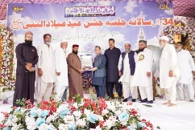

KPT hosted the 34th Annual Milad-un-Nabi gathering filled with spiritual significance on 10th October 2024, at KPT Head Office. The Naat-Khwaans and the notable scholar Mufti Muhammad Ejaz Qadri, who delivered an inspiring address to attendees, during the occasion.
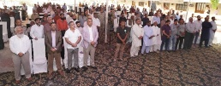
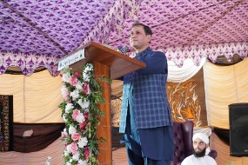
Former Chairman KPT, Syedain Raza Zaidi, attended as the chief guest. He encouraged everyone to follow the teachings of Prophet Muhammad ﷺ. He expressed his sincere gratitude to Mufti Ejaz for his enriching speech.
KPT Hosts Delegation from Pakistan Audit & Accounts Academy
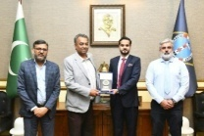
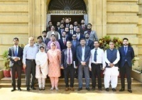
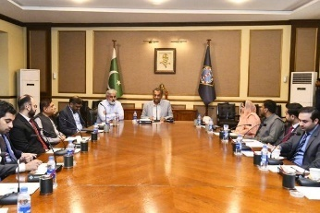
The 51st Specialized Training Program (STP) delegation of probationary officers from the Pakistan Audit & Accounts Academy visited KPT Head Office on 21st November 2024. The visit provided an excellent opportunity for the delegates to gain an insight into KPT's ongoing projects and development initiatives.
The session was chaired by Mr. Raghib ul Khair, General Manager Planning and Development. He guided the delegation through a comprehensive briefing on KPT's strategic projects and future plans. It was followed by an engaging Q&A session fostering dynamic discussion that allowed the delegates to delve into specific interest areas.
_____________________________________________________________________________
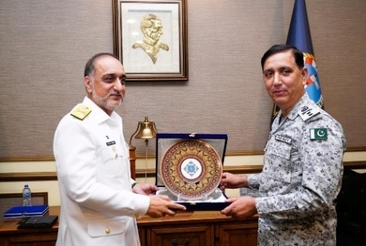
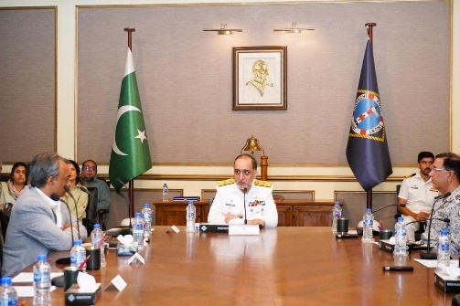
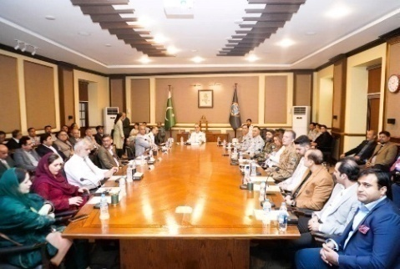
KPT Hosts Delegation from Maritime Security Workshop 2024
A high-profile delegation from the Maritime Security Workshop 2024 (MARSEW-7) visited KPT Head Office on 2nd December 2024. A thorough briefing on KPT operations and upcoming strategically important development projects of the port was shared during the occasion with the revered delegates.
The session was chaired by Vice Chairman KPT, Vice Admiral Muhammad Faisal Abbasi HI(M), who highlighted the vital role of maritime security in supporting the country’s economic growth.
Followed by the presentation, the delegation gained further from an interactive Q&A session, fostering open discussion and knowledge sharing. The visit concluded with the exchange of mementos, during the occasion.
Meeting of the Steering Committee to Facilitate Maersk Investment in Pakistan
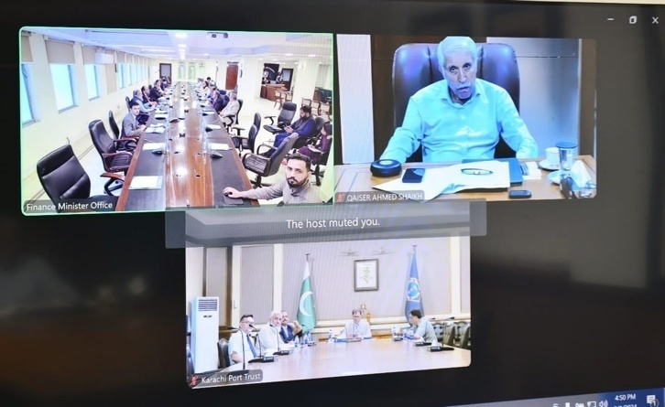
A steering committee meeting was convened to facilitate investment from Denmark in the maritime sector, specifically involving the Global Shipping leader Maersk Line. The meeting was chaired by the Federal Minister for Finance and Revenue, Mr. Aurangzeb Khan, with the Federal Minister for Maritime Affairs, Mr. Qaiser Ahmed Shaikh, participated online.Also in attendance were Federal Secretaries of Maritime Affairs and Lawalong with Chairman KPT, Syedain Raza Zaidi.
The committee reviewed the progress on the signing of a Memorandum of Understanding (MoU) between Pakistan and Denmark,focusing on a public-private partnership for sustainable infrastructure development.
In May 2024, Danish shipping giant AP Moller – Maersk (MAERSK) announced its plans to invest billions of US dollars into Pakistan’s maritime infrastructure, particularly at Karachi Port. This investment will enhance the port’s infrastructure, logistics warehousing, shipbreaking, and overall port development.
Syed Zafar Ali Shah Makes Maiden Visit to KPT as Secretary MoMA
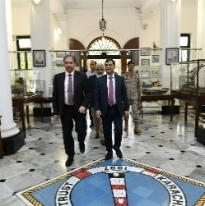
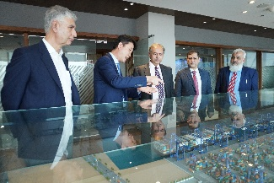
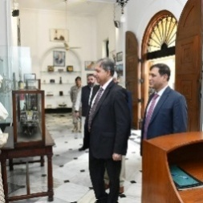
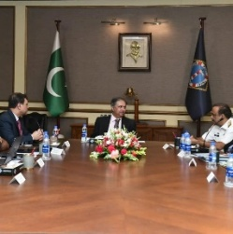
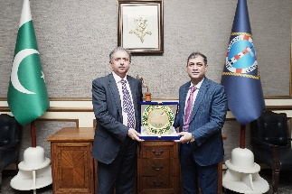
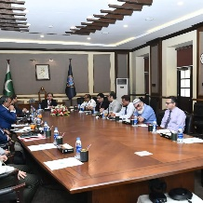
Karachi Port Trust welcomed Syed Zafar Ali Shah on his first official visit after assuming the charge as Secretary, Ministry of Maritime Affairs (MoMA) on 4th July 2024. Chairman KPT, along with General Managers, provided a comprehensive briefing on KPT’s operations, upcoming development projects, and real estate business strategies.
During the visit, Secretary Zafar Ali Shah was given a detailed overview of port operations and the strategic initiatives that aim to enhance the effectiveness and efficiency of KPT's services. Discussions focused onkey upcoming development projects aimed at increasing the port’s capacity and improving its infrastructure.
In addition to the briefing, Secretary visited the South Asia Pakistan Terminals Limited (SAPTL), where he witnessed the cargo handling processes, gaining valuable insights into KPT’s operational capabilities and those of its terminals.
The visit concluded on a positive note with the presentation of a shield and souvenir to Secretary,Syed Zafar Ali Shah, symbolizing the strong commitment and collaborative spirit between KPT and the Ministry of Maritime Affairs. This visit marked a significant step in strengthening cooperation and communication between KPT and the ministry, pavingthe way for the advancement of port operations and development initiatives.

Chairman KPT hoists National Flag at KPT Head Office to mark the 77thIndependence Day OfPakistan (02 pages and include all events of 14th august)
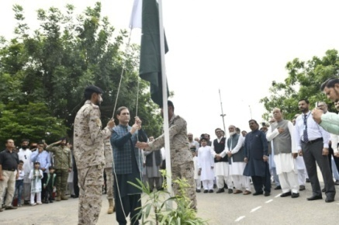
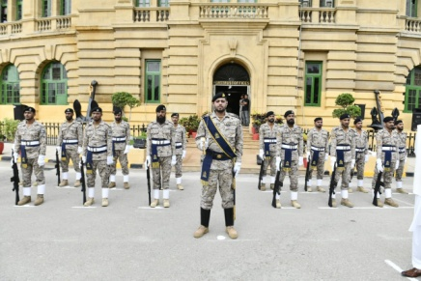
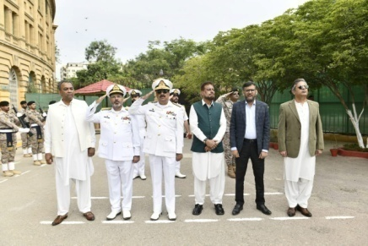
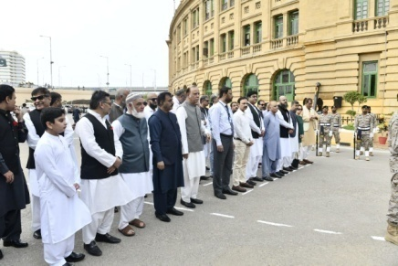
Karachi Port Trust celebrated 77thIndependence Day of Pakistan with great national fervor, zeal and enthusiasm at KPT Head Office.Chairman KPT, Syedain Raza Zaidi graced the occasion as Chief Guest, accompanied by all General Managers and Heads of Departments. The Celebrations began with the sounding of Sirens for 2 minutes symbolizing national unity and reflection. This was followed by the hoisting of the national flag by Chairman KPT. After the flag was raised high, the Chairman reviewed a Guard of Honor presented by the Port Security Force, adding a sense of pride and solemnity to the occasion.
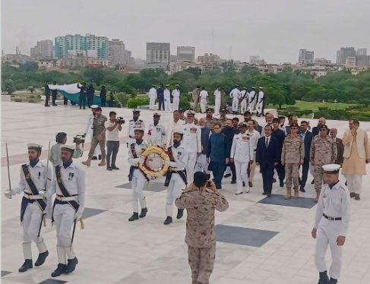
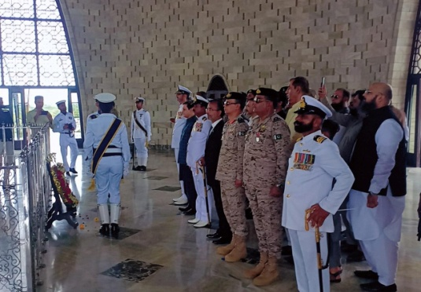
In his address, Chairman KPT emphasized the virtuous and cost of independence and selfless contributions and sacrifices of our forefathers in the creation of Pakistan, honoring those who have made supreme sacrifices to secure and preserve this invaluable independence. After the culmination of simple but graceful flag hoisting ceremony, the Chairman, along with senior officials, proceeded to the Quaid-e-Azam Mausoleum to offer prayers and pay homage to the Father of the Nation, Quaid-e-Azam Muhammad Ali Jinnah. This visit underscored the enduring legacy of the Quaid’s vision for a prosperous and independent Pakistan.
National Assembly Standing Committee on Maritime Affairs Meets at KPT Head Office
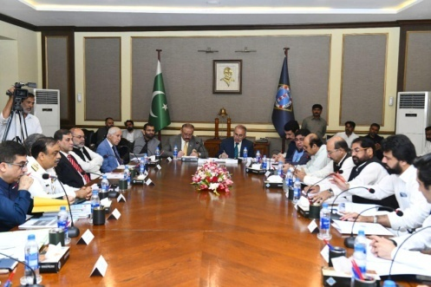
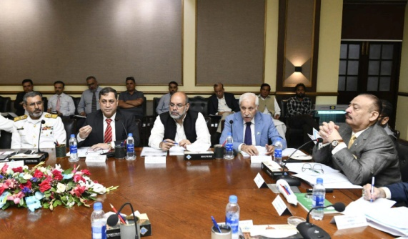
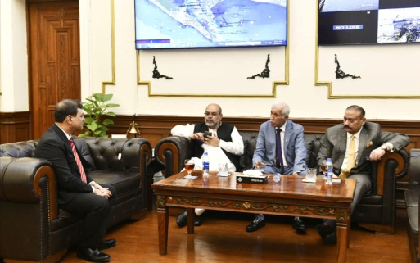
A meeting of the National Assembly Standing Committee on Maritime Affairs was held at Karachi Port Trust Head Office on 26th September 2024. The session was chaired by Mr. Abdul Qadir Patel, MNA, and Chairman of the NA Standing Committee, and brought together key stakeholders in the maritime sector.
Attendees included the Minister for Maritime Affairs, Qaiser Ahmed Shaikh, the Additional Secretary of the Ministry of Maritime Affairs (MoMA), Chairman KPT, Syedain Raza Zaidi as well as KPT’s General Managers and members of the standing committee. The gathering aimed to discuss important issues affecting the maritime industry and review policies essential for the sector's growth and sustainability.
During the meeting, various topics were addressed, including port operations, maritime safety, and the role of KPT in boosting trade and economic development in Pakistan. The committee highlights the importance of collaborative efforts to address the challenges and promote more efficient maritime practices.
Chairman Abdul Qadir Patel praised KPT’s efforts in facilitating maritime trade and highlighted the importance of continuous dialogue between the government and port authorities to ensure progress within the sector.
The meeting concluded with a commitment to work together towards strengthening Pakistan’s maritime infrastructure and enhancing its position as a key player in regional trade.
British Delegation Visits Karachi Port for Strategic Discussions
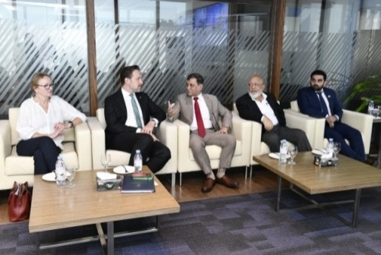
Karachi Port Trust welcomed a delegation from the United Kingdom, led by Mr. Oliver Christian, His Majesty's, Trade Commissioner for the Middle East and Pakistan, accompanied by Sarah Mooney, British Deputy High Commissioner in Karachi. The delegation visited the South Asia Pakistan Terminals (SAPTL) to gain insights into KPT's operations and explore potential collaboration opportunities.
During their visit, the delegation received an in-depth briefing on the strategic initiatives undertaken by KPT and SAPTL. The discussions centered on enhancing trade relations and exploring avenues for investment in Pakistan's maritime sector.
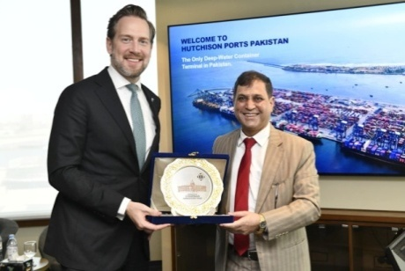
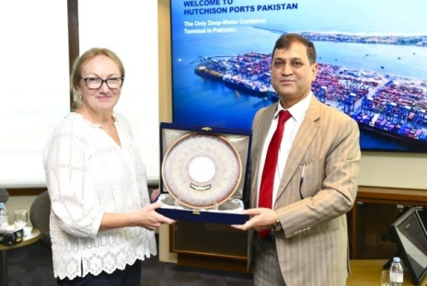
Chairman, Syedain Raza Zaidi warmly welcomed the delegation, reaffirmin KPT's commitment to fostering international partnerships that drive economic growth and development. He emphasied, "Collaboration with international stakeholders is crucial for enhancing our capabilities and expanding trade. We are eager to explore mutually beneficial opportunities that will strengthen our maritime infrastructure."
Mr. Oliver Christian highlighted the UK's interest in expanding trade ties with Pakistan, underlying the importance of the maritime sector in facilitating economic growth. He remarked, "The UK is keen to invest in Pakistan’s infrastructure, and our discussions today have reaffirmed the potential for strengthening our collaborations in the maritime domain."
The visit concluded with a shared commitment to ongoing dialogue and cooperation, paving the way for future partnerships that will enhance the efficiency and sustainability of the maritime industry.

Security Arrangements & Measures at Karachi Port by Port Security Force
Throughout FY 2024-25, Karachi Port Security Force (PSF) maintained robust security protocols during major events, including IMSEC-2024 with IMO Secretary General, multinational exercises AMAN & AMAN Dialogue, and ceremonial functions like wreath-laying at Mazar-e-Quaid. PSF's professional security management, en-route and venue security, traffic control, intelligence cover, and coordination with LEAs earned high praise from stakeholders, IMO officials, and KPT.
To enhance port security, new measures were instituted:
- The Security Officer of the Day (SOOD) system ensures 24/7 port monitoring.
- Established a Central Quick Response Force (QRF) and a dedicated armory.
- Heightened port area security, thwarted thefts, and handed over culprits.
- Upgraded compliance with ISPS Code, with SOPs implemented at all facilities.
- SOPs for Foreigners/Chinese Nationals' safety were introduced.

KPT improved operations:
- Entry pass issuance procedures were streamlined, reducing issuance time from 15 to 7 days, issuing 2,729 permanent passes and earning Rs. 20.8M.
- Temporary passes issued 612,752, generating Rs. 45.9M revenue.
Capacity building initiatives included:
- Procurement of advanced arms, ammunition, operational vehicles, bulletproof jackets, and CCTV coverage.
- Implementation of walk-through gates, explosive detectors, and welfare activities for PSF personnel.
- Training programs aligned with ISPS standards are underway, facilitated by the Ministry of Maritime Affairs.
Accountability measures ensure transparent management of store items and uniforms. Regular refresher training, mock drills, SOPs for drone/IED attacks, and security exercises bolster preparedness. No breaches occurred during FY 2024-25, enabling port operations to continue securely during major events.

TRAINING & DEVELOPMENTS
Training and Development of Human Resources are the Integral part and function of organizational Development Department. In this regard, KPT facilitates to arrange workshops, seminars, short courses, etc. for the officers and employees. These are as follows.

S.NO |  | SUBJECT |  |  | DATE |  | CONDUCTED BY |  |  |  |  |  |  | PARTICIPANTS
 |  | Awareness Session on Heat Stroke |  |  | 02 July 2024 |  | Dr. Mishal |  |  |  |  |  |  | 71
 |  | My Story and Story of Akhuwwat |  |  | 05 July 2024 |  | Dr. Amjad Saqib |  |  |  |  |  |  | 62
 |  | Strategic management |  |  | 18-19 July 2024 |  | Malik Babar Rashid |  |  |  |  |  |  | 89
 |  | Presentation skills for managers |  |  | 29- July-2024 |  | Norin Farhan |  |  |  |  |  |  | 30
 |  | Negotiation skills |  |  | 30- July-2024 |  | Sohail M. Ali |  |  |  |  |  |  | 29
 |  | Pillars & importance  Of institutional harmony” |  |  | 02-Aug-2024 |  | Mr. Raza Rabbani , Ex-Chairman Senate |  |  |  |  |  |  | 76
 |  | Transforming  Pakistan into  Foreign investment  Country accruing  Maximum benefit in  Growing asian  Markets |  |  | 15- Aug -2024 |  | Mr. Arif Habib, Founder & CEO Arif Habib Group |  |  |  |  |  |  | 75
 |  | 02 Days Course on  “Handling difficult  people” & “Teamwork,  Getting people to  Work together |  |  | 15 & 16  Aug-2024 |  | Nourin Farhan, Sohail. M. Ali  Guest Speakers |  |  |  |  |  |  | 29
 |  | Workshop on  Enhancing Operational efficiency in ports to address cross cutting issues faced by ports |  |  | 29- Aug -24 |  | MOMA |  |  |  |  |  |  | 21
 |  | Mushaera |  |  | 31- Aug -2024 |  | Arranged by Dr. Zaigham Jafri |  |  |  |  |  |  | 50
 |  | 02 Day course on  microsoft office” |  |  | 02-03 Sept 2024 |  | Sumaira Ghori Guest Speaker |  |  |  |  |  |  | 48
 |  | One day Session on “Stress Management” . |  |  | 26-Sept, 2024 |  | Mr. Waqar Azeem, XEN, Engineering Department |  |  |  |  |  |  | 56
 |  | One day Seminar on Navigating the Future: Safety First---Celebrating World Maritime Day |  |  | 27-Sept,2024 |  | Mr. Rashid Yahya Usmani, Director, (Enviro – Maritime Capacity Building Institute) |  |  |  |  |  |  | 80
 |  | One Day Session on “Skills In Goal Setting And Work Planning” |  |  | 04-Oct-2024 |  | Mr. Sohail Muhammad Ali, Corporate Trainer |  |  |  |  |  |  | 54
 |  | One Day Session on “Emotional Development” |  |  | 11- Oct -2024 |  | Nourin Farhan, Sohail. M. Ali  Guest Speakers |  |  |  |  |  |  | 55
 |  | One Day Session On “Challenges To Control Marine Pollution in Pakistan and Way Forward” |  |  | 15- Oct -2024 |  | Mr. Farhan Anwar, Lead Author of the Pakistan’s National Strategy and Action Plan for the Mangroves of the Future Regional Program |  |  |  |  |  |  | 55
 |  | One Day Awareness Session on “Breast Cancer” |  |  | 22-Oct-2024 |  | Dr. Fareya Usmani (Consultant General & Breast Surgeon) at OMI Hospital |  |  |  |  |  |  | 65
 |  | One Day Session on “ Positive Attitude Towards Work” |  |  | 23- Oct -2024 |  | Muhammad Abdul Malik, Dy. Manager OD |  |  |  |  |  |  | 35
 |  | Management Course For Junior ExecutiveS |  |  | 30- Oct -2024 |  | Ms. Sumaira Ghouri, Corporate Trainer |  |  |  |  |  |  | 55
 |  | One Day Session on “Problem Solving and Decision Making Skills” |  |  | 06-Nov-2024 |  | Guest Speaker Mr. Mustafa Humayun Baghpati |  |  |  |  |  |  | 35
 |  | 02 Days Session (II) Recap of EPADS Module |  |  | 05-06 Nov’2024 |  | Mr. Rizwan Mehmood, Director MIS, PMU, PPRA, GOP |  |  |  |  |  |  | 65
 |  | One Day Course on “Importance Of Discipline & How to Enhance Morale, Motivation At Work” |  |  | 28-Nov-2024 |  | Mr. Malik Babar Rashid, Asst. Manager Stores |  |  |  |  |  |  | 40
 |  | One Day Course on “Financial Management &  Budgeting” |  |  | 09-Dec-2024 |  | Mr. Sandeep Kumar Talib, Ag. CAO |  |  |  |  |  |  | 61
 |  | Visit/Presentation for Air War Course No. 38 of PAF War College Institute Faisal, Karachi by Commandant PSF |  |  | 09- Dec -2024 |  | Presented By Commandant PSF |  |  |  |  |  |  | 100
 |  | 01 Day Course on “Communication Skills” |  |  | 12- Dec -2024 |  | Guest Speaker Mr. Mustafa Humayun Baghpati |  |  |  |  |  |  | 45
 |  | Recreational Excursion Visit For Senior Civil Judges from KPK High Court |  |  | 20- Dec -2024 |  | KPT |  |  |  |  |  |  | 23
 |  | Lecture on “Leadership and Motivational Skills” |  |  | 22-Jan-2025 |  | Guest Speaker Ms. Naurin Farhan |  |  |  |  |  |  | 90
 |  | Utilization of E-office Correspondence with Ministries /Division/Departments |  |  | 23-Jan-2025 |  | MIS |  |  |  |  |  |  | 63
 |  | Utilization of E-office Correspondence with Ministries /Division/Departments |  |  | 4-Feb-2025 |  | MIS |  |  |  |  |  |  | 23
 |  | Study Tour Ex-Sardar Bahadur Khan Women University, Khuzdar |  |  | 14 Feb’ 2025 |  | KPT Staff College |  |  |  |  |  |  | 55
 |  | Instructional visit of 64th senior management course |  |  | 18-Feb, 2025 |  | KPT Staff College |  |  |  |  |  |  | 33
 |  | Utilization of E-office Correspondence with Ministries /Division/Departments |  |  | 26- Feb, 2025 |  | NITB Officials |  |  |  |  |  |  | 77
 |  | Seminar on “World Cancer day 2025” |  |  | 27-Feb’ 2025 |  | Dr. Khalil, Oncologist / Dr. Sana pediatrician |  |  |  |  |  |  | 57
 |  | Seminar on “Women Empowerment” on International Women Day. |  |  | 18-Feb’ 2025 |  | Ms. Naurin Farhan |  |  |  |  |  |  | 64
 |  | Awareness Session on ‘World Health Day” on the Topic of Common Skin Disease. |  |  | 10-Mar-2025 |  | Dr. Kashef Ahmed Malick (Skin Specialist) |  |  |  |  |  |  | 63
 |  | Awareness Session on “Road Safety” |  |  | 22-Apr-2025 |  | Mr. Farasat Ali Bhinder, DSP, Beat-01, Hub, NHMP |  |  |  |  |  |  | 66
 |  | Awareness Session On Marine Insurance And Dispute Resolution at KPT  Staff College.  (for officers) |  |  | 24-Apr-2025 |  | Guest Speaker from Singapore Mr. Muthu Jagannath, Fellow ICS and Director at NAU Pte Ltd Institute of Chartered Shipbrokers (ICS) |  |  |  |  |  |  | 50
 |  | Awareness Session on Earth Day -2025 “Our Power, Our Planet”. |  |  | 25-Apr-2025 |  | Mr. Rashid Yahya Usmani, Ex-Manager MPCD |  |  |  |  |  |  | 54
 |  | 01 Day Course On “Objectivity & Critical Thinking; Problem Solving & Decision Making Skills” |  |  | 08-May-2025 |  | Guest Speaker  Mr. Sohail Muhammad Ali |  |  |  |  |  |  | 52
 |  | 01 Day Course On  “Discipline And Time Management; Personality Development & Interpersonal Skills” |  |  | 15- May -2025 |  | Mr. Malik Babar Rashid,  Asst. Manager Stores/Tech. Co-ord to GM(E) |  |  |  |  |  |  | 55
 |  | Two-days Course On “Assessing Network & Cyber Security Threat/Social Media Awareness” |  |  | 21- May -2025  22- May -2025 |  | Mr. Naresh (MIS)  Mr. Adnan (MIS) |  |  |  |  |  |  | 63
 |  | Two-days Course On “Emotional Intelligence & Stress Management” |  |  | 26- May -2025  27- May -2025 |  | Mr. Waqar Azeem, XEN, Engineering Department |  |  |  |  |  |  | 41
 |  | One Day Session on “Pakistan Space Based Augmentation System” |  |  | 29- May -2025 |  | By SUPARCO |  |  |  |  |  |  | 20
 |  | One Day Session on  NBP Products |  |  | 03-Jun-2025 |  | NBP Rep. |  |  |  |  |  |  | 47
 |  | One Day Session on  “Communication Skills & Goal Setting And Work Planning” |  |  | 18-Jun-2025 |  | Sumera Ghouri, Guest Speaker |  |  |  |  |  |  | 43
Total courses/workshops/seminars/Activities |  |  |  |  |  |  | 45 |  |  |  |  |  |  | 2420
 | COURSES (OUT OF STAFF COLLEGE)
 | S.NO |  | SUBJECT |  |  | DATE |  |  |  | CONDUCTED BY |  |  | PARTICIPANTS
 |  |  | International Maritime Summer School Program On (Energy Efficiency Measures For Ports & Shipping Industry) |  |  | 19-23 Aug’2024 |  |  |  | Bahria University |  |  | 05
 |  |  | 03 Months Diploma In “Industrial Relation & Labour Laws” |  |  | 11 Aug-10 Nov 24 |  |  |  | PIM, Karachi |  |  | 01
 |  |  | Inception Workshop On Safe And Environmentally Sound Ship Recycling (Sensrec), By International Maritime Organization |  |  | 16TH Sept 2024 |  |  |  | By IMO at Movenpic KHI  (FREE OF COST) |  |  | 05
 |  |  | Fireman Course No Fm-172 From |  |  | 28-10-2024 TO 15-11-2024 |  |  |  | Federal Civil Defense Training School |  |  | 02
 |  |  | 24 week 62nd Post Graduate Diploma Course in Labour  Administration and Industrial Welfare |  |  | 14th Oct, 2024 to 28th March, 2025 |  |  |  | NILAT |  |  | 01
 |  |  | 36th SMC |  |  | 09 Sept to 27 Dec 2024 |  |  |  | NIM, KHI |  |  | 02
 |  |  | 41st MCMC |  |  | 19 Aug to 25 Oct, 2024, |  |  |  | NIM, KHI |  |  | 01
 |  |  | Fire Prevention & Safety Course  No. Fps-35 (for ladies)  Free of cost |  |  | FROM 18-11-2024 TO 29-11-2024. |  |  |  | Federal Civil Defense Training School, KHI |  |  | 08
 |  |  | Civil Defence General Instructor Course No. GI-43 (for ladies)  Free of cost |  |  | FROM 02-12-2024 TO 27-12-2024 |  |  |  | Federal Civil Defense Training School, KHI |  |  | 08
 |  |  |  |  |  | Total |  |  |  | 09 courses |  |  | 33 Participants
COURSES (OUT OF CITY)
S.NO |  |  | SUBJECT | DATE |  |  |  | CONDUCTED  BY |  |  |  | PARTICIPANTS
 |  |  | Improvised Explosive  Device Disposal  Course no. 100 | 09-09-24  TO 04-10-24 |  |  |  | Bomb Disposal Unit HQ, Lahore |  |  |  | 02
 |  |  | Maritime Security Workshop (MARSEW-7) with the theme of “secure seas – prosperous pakistan” | 26 Nov -05 Dec 2024 |  |  |  | At Pakistan Navy War College, Lahore |  |  |  | 01
 |  |  |  | Total |  |  |  | 02 courses |  |  |  | 03 Participants
ONLINE WORKSHOP
S.NO |  |  | SUBJECT | DATE |  |  |  |  | CONDUCTED  BY |  | PARTICIPANTS
 |  |  | Pak Virtual Sub-Regional Workshop For Maritime Adminstrators On The Implementation Of Imo Member State Audit Scheme (IMSAS)  (online workshop) | 30 Sept- 04 Oct 2024 |  |  |  |  | IMSAS  (Implementation of IMO Members State Audit Scheme) |  | Ashhad Riaz Rajput  Manager Port Safety  Azhar sultan ATM Traffic
 |  |  |  | TOTAL |  |  |  |  | 01 course |  | 02

SPORTS
Sports Department KPT, plays a vital role for the development of Sports & Sportsmen by organizing various International/ National level competitions, games & sports activities throughout the year at KPT Sports Complex. Moreover, following are the significant events / major Achievements & Developments projects of Sports department.
KPT Sports Department Hosts Ramadan Snooker Cup 2025


The KPT Sports Department proudly broke the frame of the Ramadan Snooker Cup 2025 on 5th March 2025 in collaboration with WHS and Woodpecker at the KPT Sports Complex, Karachi. The Opening Ceremony featured Brig Muhammad Younis, General Manager Administration, as the Chief Guest, with World Snooker Champion Mr. Muhammad Yousaf Khan as Guest of Honour.
This exciting tournament showcased 56 talented players from across Sindh, competing for the prestigious title which concluded on 18th March 2025 with the prize distribution ceremony. Winners, runners up, semi finalists and Excellent Break of Tournament players received medals and trophies from Mayor Karachi Barrister Murtaza Wahab during the occasion.

KPT Boys Secondary School Achieves Second Place in Tug of War

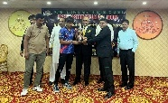
KPT Boys Secondary School (Keamari) has clinched second position in the Tug of War event organized by the Board of Secondary Education Karachi in 2024. The trophy was awarded on February 27, 2025, by Syed Sharaf Ali Shah, Chairman of the Board of Secondary Education, Karachi which was received by the Manager Education KPT Syed Faisal Ijaz.
______________________________________________________________________________

KPT's Iqbal Sheikh Shines at Veterans World Cup Cricket Tournament
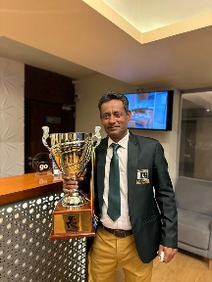
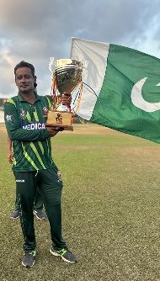
KPT Sports Supervisor Mr. Iqbal Sheikh has made history as the first KPT cricketer to participate in the Veterans World Cup Cricket Tournament in Colombo, Sri Lanka. With an impressive 30-year career, he has represented the KPT cricket team in the Quaid-e-Azam Trophy and other national events.
Iqbal's outstanding performance of 55 runs helped Pakistan secure victory against Sri Lanka in the tournament final, enabling the team to lift the coveted trophy. His cricket journey began in the Karachi region, where he played Under-19 for Karachi Whites and Blues, attended the Pakistan youth camp, and participated in various tournaments, including the Wills Cup and One Day Cup. He has also played in leagues in England and the Bangladesh Premier League.
Currently serving as Head of Cricket at KPT, Iqbal has been actively involved in veterans cricket for 12 years and serves as a Head Coach in Karachi Zone 7. Congratulations to Mr. Iqbal Sheikh for his remarkable achievements and representation of KPT on the international stage!
41st National Elite Men’s and 5th National Elite Women’s Boxing Championship Concludes at KPT Sports Complex
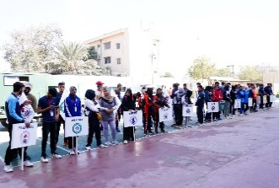
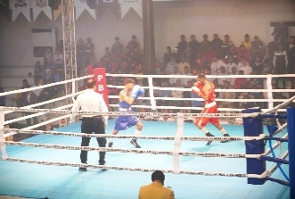
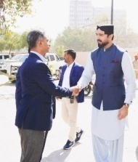
The 41st National Elite Men’s and 5th National Elite Women’s Boxing Championship held at the KPT Sports Complex from 10th to 15th February, 2025. This prestigious event featured male and female boxers competing in various weight categories which was organized by the Pakistan Boxing Federation with the support of Pakistan Army.

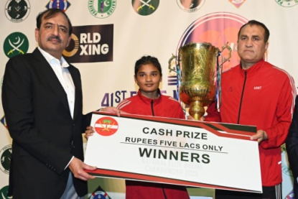
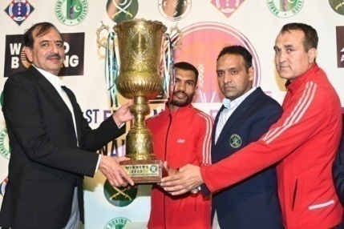
With over 300 participants from the various participating teams, the championship throughout ensured compliance with the international standards. In the male category, the Pakistan Army claimed first place, followed by Pakistan Navy and WAPDA. In the female category, the Pakistan Army also secured the top spot, with Punjab and WAPDA finishing second and third, respectively.
Corps Commander Karachi Lt Gen Muhammad Avais Dastgir, the chief guest, distributed prizes while praising the boxers’ performances during the occasion. He also opined that the event would elevate present standards of Pakistani boxers and project them internationally.

Successful Inter-Divisional Badminton & Volleyball Competitions 2025
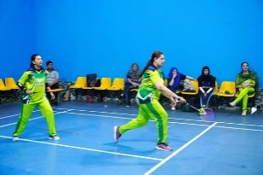
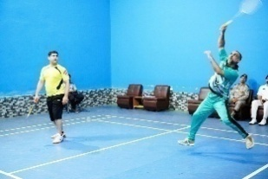
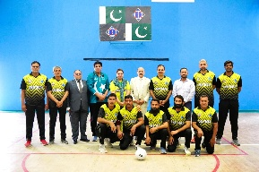
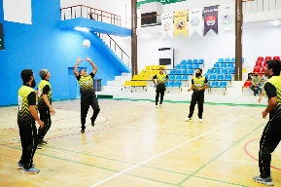
The KPT Inter-Divisional Badminton and Volleyball Competitions - 2025 took place from 18th to 24th February, 2025 at the KPT Sports Complex, showcasing the talent and enthusiasm of the KPT workforce. The tournament was inaugurated by the Chief Guest, Rear Admiral Ateeq Ur Rehman Abid SI(M), KPT General Manager Operations. He also represented the Operations Division in the opening match of the badminton doubles against the Engineering Division.
Throughout the tournament, teams of each Division competed against the other in Volleyball whereas only doubles Badminton teams of each Division participated against each other to qualify for semi finals and finals of both Volleyball and Badminton. The championship concluded on 24th February, 2025, with enthusiastic participation from all participating players who demonstrated exceptional finesse and competitive skills throughout the tournament.
In Volleyball, the Operations Division emerged as the champion, while in Badminton, the Finance Division secured victory in the Men's category, and the Administration Division triumphed in the Women’s category.
While speaking during the concluding ceremony occasion, the chief guest, Chairman KPT Rear Admiral Habib-ur-Rehman HI(M), appreciated the outstanding performances of players and conduct of the tournament in such a short notice. Later, he awarded medals and trophies to the position holders to conclude the proceedings.
KPT and Karachi Boat Club Host Successful Indoor Rowing Regatta 2024
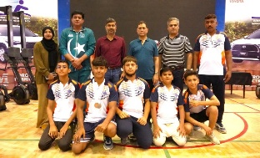
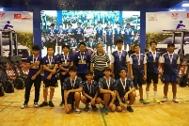
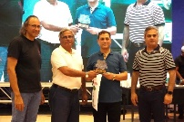
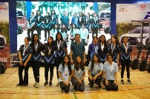
The Annual Karachi Boat Club Indoor Rowing Regatta Competition was held at the KPT Sports Complex, organized by the Karachi Boat Club in collaboration with Karachi Port Trust on 27th October 2024. This highly anticipated event attracted an impressive turnout of 650 students from 32 different schools, colleges, and universities, including esteemed institutions such as Karachi Grammar School, Cedar College, Nexor, and Agha Khan University.
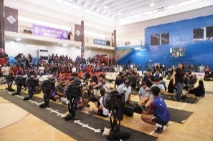
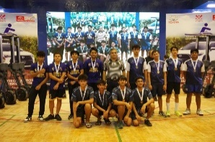
The then Chairman KPT distributed medals along with Mr. nadeem Kazmi, President of the Boat Club and praised the efforts of the players, officials, and organizers, for their commitment in promoting rowing and fostering sportsmanship among the youth.

KPT Hosts 7th Men's National Softball Championship 2024
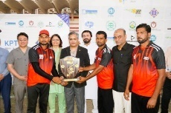
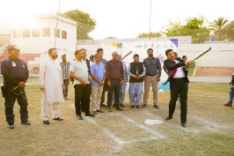
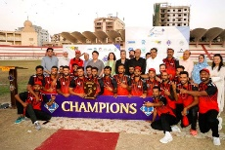
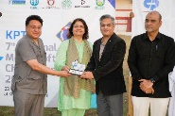
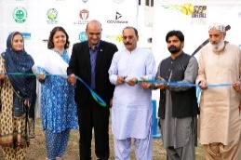
KPT hosted the 7th Men’s National Softball Championship 2024 at the KPT Sports Complex in Karachi. The event officially inaugurated by Mr. Jalal ud Din Mehar, Secretary of the Youth Affairs & Sports Department, Sindh, alongside Syed Ghazanfar Ali, Additional Commissioner of Karachi, and other distinguished guests. This championship brought together teams from across the country, fostering a spirit of competition and camaraderie among athletes, while promoting softball as a vibrant sports in Pakistan.
Army team claimed the title after a decisive 12-3 victory over WAPDA in just 7 innings. The then General Manager Administration Brig Tariq Bashir and the CEO Dr Essa Laboratory Dr. Farhan Essa Abdullah presented the championship trophy and medals to the winners and runners-up during the concluding proceedings of the championship on 25th October 2024.
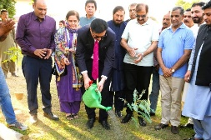
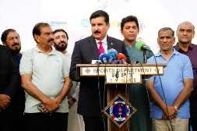
During the championship, KPT also held a Tree Plantation Drive in partnership with Syed Foundation. The campaign was graced by Mr. Faisal Karim Kundi, Governor of Khyber Pakhtunkhwa, who planted a tree sapling as Chief Guest and praised the efforts of the players, officials, and organizing committee to promote sports and healthy activities among youth.
___________________________________________________________________________
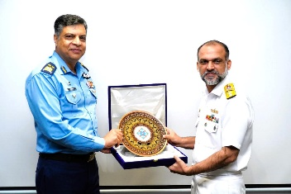
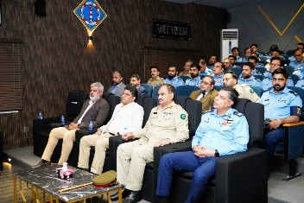
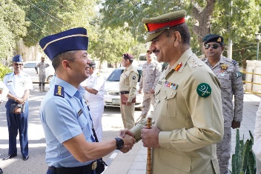
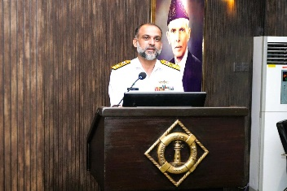
Delegation from PAF War College Institute Visits KPT
KPT hosted a delegation from the PAF War College Institute, Faisal, on December 9, 2024, at the KPT Staff College as part of their inland study tour. The delegation received a comprehensive presentation on port operations, highlighting the organization structure, roles, and notable achievements of KPT.
The visit concluded with the exchange of mementos, symbolizing the collaboration and shared learning between KPT and the PAF War College Institute.
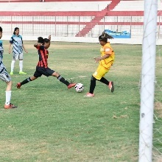
National Women Football Clubs Matches Held at KPT Sports Complex
The KPT Sports Complex hosted the National Women Football Clubs Matches, Round 1 for the Sindh Zone, from 21stto 28thJuly, 2024. The tournament featured participation from thirteen club teams, showcasing the growing talent and passion for women's football in the region.
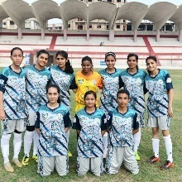
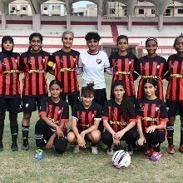
The event showcased a thrilling display of skill and sportsmanship, jointly organized and sponsored by the Pakistan Football Federation and the KPT Sports Department. It aimed to promote women's football and provide a platform for female athletes to shine.
In conjunction with this event, the initial stage of the National Women’s Football Club Championship 2024 concluded across Islamabad, Karachi, Lahore, and Quetta.

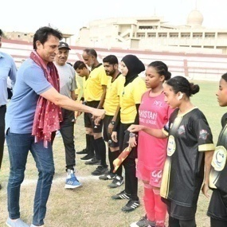
Former Cricketer Mr. Younis Khan Inspires at National Inter-Club Women's Football Championship 2024
In a remarkable show of support for women's sports, legendary cricketer and former Pakistan captain Mr. Younis Khan visited the KPT Football Stadium on 25th July 2024 during the National Inter-Club Women's Football Championship 2024.
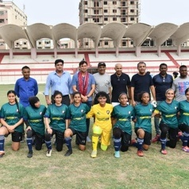
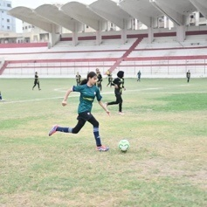
During his visit, Mr. Younis Khan interacted with the teams from Karachi United Women Football Club and the Muhammad Umar Kareem Women Football Club. He motivated the participants with his encouraging words and expressed admiration for their dedication and talent on the field.
Mr. Younis also praised the officials and KPT management for their excellent arrangements, which significantly contributed to the success of the championship. His presence not only boosted the morale of the players but also highlighted the importance of promoting women's sports in the country.

6th KPT Squash Championship 2024 Celebrates 77th Independence Day
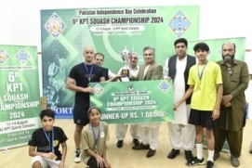
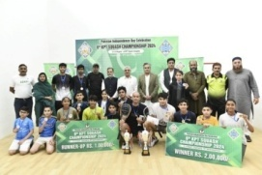
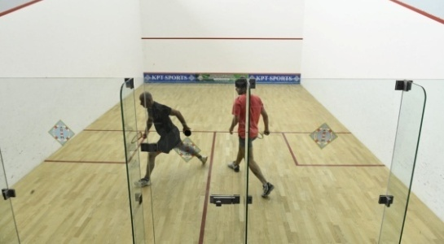
The 6th KPT Squash Championship 2024 held at the KPT Sports Complex to commemorate the 77th Independence Day. During the concluding ceremony, Brigadier Tariq Bashir, General Manager Administration, along with Former World Squash Champion Mr. Maqsood Ahmed, presented medals and awards to the players on behalf of KPT Chairman Syedain Raza Zaidi. The event showcased exceptional talent and sportsmanship, bringing together the community in celebration of national pride and athletic excellence.
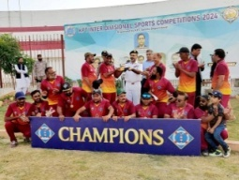
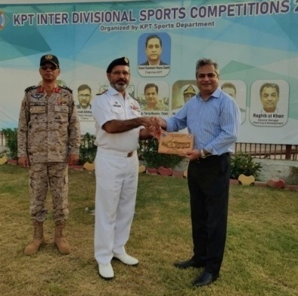
KPT organized Inter-Divisional Cricket Championship 2024
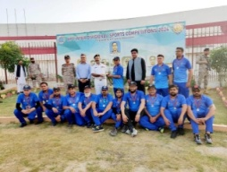
The KPT Inter-Divisional Cricket Championship 2024 concluded on 23rd August 2024 at the KPT Sports Complex. The tournament, which began on 21stAugust, 2024, featured enthusiastic participation from cricket teams across all KPT divisions, filled with joy and zeal.
Rear Admiral Habib ur Rehman HI(M), General Manager Engineering, graced the occasion as the Chief Guest and presented trophies and medals to the winning and runner-up teams.
In a thrilling final, the Engineering Division emerged victorious, claiming the trophy after a nail-biting match against the Finance Division.
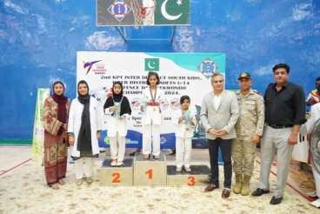
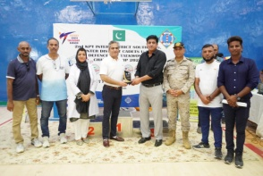
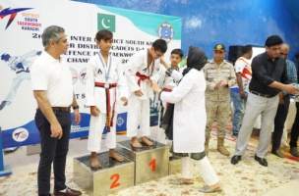
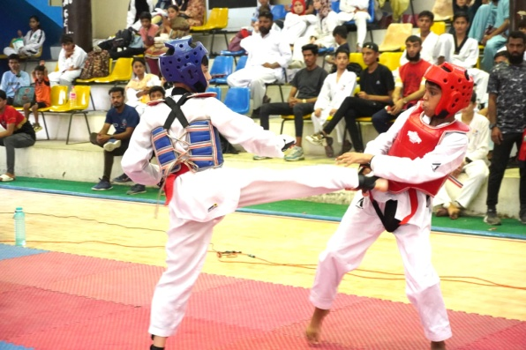
2ndKPT Taekwondo Championship 2024: A Showcase of Talent and Sportsmanship
KPT organized 2ndKPT Taekwondo Championship 2024 at the KPT Sports Complex, witnessing an impressive turnout of over 150 boys and girls from all districts of Karachi. Brig. Tariq Bashir TI (M), General Manager Administration KPT, graced the event as Chief Guest. During the closing ceremony, he distributed medals and shields to the worthy winners, celebrating their hard work and dedication.
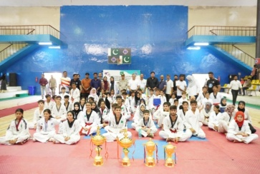
The championship brought together a diverse group of young athletes, showcasing their skills and competitive spirit. Participants displayed remarkable talent across various weight categories, making the event an exhilarating experience for both competitors and spectators alike.

Developments Projects in Sports Department:

- Establishment of State of the art Gym / Fitness center at KPT Sports Complex
- To set up a Paddle Tennis & Indoor cricket arena
- Tartan Track (Jogging/Walking)
- Uplifting of sports venues / infrastructure ( KPT Football Stadium, Cricket ground / Jinnah Hall ( Volleyball court) for smooth conducting of games / activities
- To conduct All Karachi Women Football Championship (August 2025)
- To organize Inter- Provincial Boxing Championship – 2025, on the occasion of 14th August 2025
- To conduct 35th National Games 2025 (Football) in collaboration with Government of Sindh in December 2025
- CSR Sports activities will be held to engage the youth of Keamari, Lyari and surrounding under privileged areas.

NET SURPLUS FOR THE YEAR
Rs. In Million
DESCRIPTION | 2023-24 | 2024-25
DESCRIPTION | 12 Months | 12 Months
Operating Income | 44,740 | 50,923
Investment Income | 5,620 | 11,117
Other Income | 549 | 550
Total Revenues | 50,909 | 62,590
Operating Expenditure | 31,950 | 32,750
Financing Cost | 2,620 | 2,530
Total Expenditures | 34,570 | 35,280
Surplus for the year before Tax | 16,339 | 27,310
Less Annual Tax 39% | (6,372) | (10,651)
Surplus for the year After Tax | 9,967 | 16,659

